CLIMATE CONTROLLED 3D PRINTER

GEORDIE MCCLELLAND

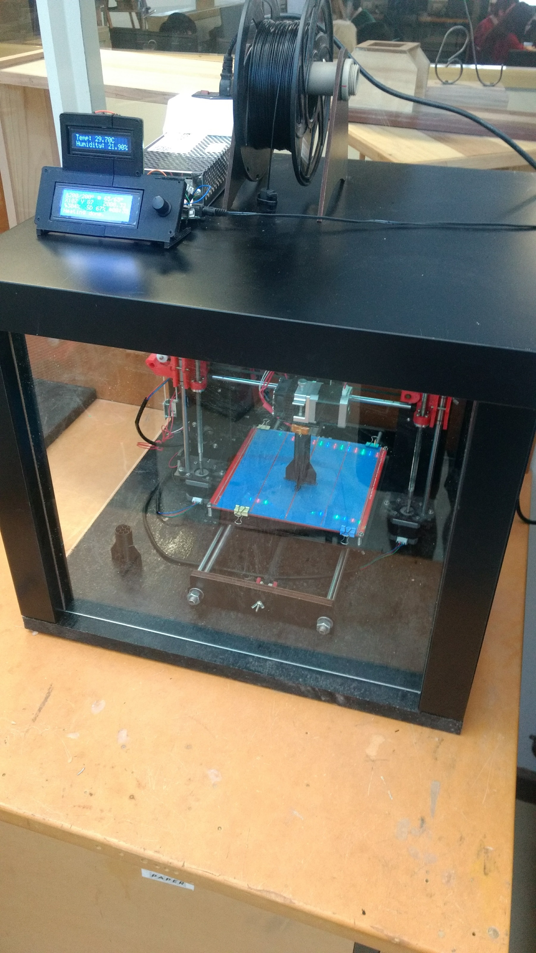

**Contents**

[Design Brief. 3](#_Toc492550696)

[Research. 7](#_Toc492550697)

[Component sourcing 10](#_Toc492550698)

[Material Sourcing 13](#_Toc492550699)

[Design Ideation. 15](#_Toc492550700)

[Final Design. 20](#_Toc492550701)

[Working Drawings. 22](#_Toc492550702)

[Circuit Design 23](#_Toc492550703)

[Enclosure 24](#_Toc492550704)

[Extruder 25](#_Toc492550705)

[Fan mount/duct V2 27](#_Toc492550706)

[E3D V6 Hotend mount 28](#_Toc492550707)

[Parts/tools list. 29](#_Toc492550708)

[Production plan. 32](#_Toc492550709)

[Steps 32](#_Toc492550710)

[GANTT chart 34](#_Toc492550711)

[Risk Assessment 35](#_Toc492550712)

[Production. 36](#_Toc492550713)

[Power supply cover (redesign) 38](#_Toc492550714)

[Fan Mount\Duct 44](#_Toc492550715)

[Extruder (redesign) 46](#_Toc492550716)

[Testing. 60](#_Toc492550717)

[Evaluation. 63](#_Toc492550718)

[**Appendix of 3D printing terminology** 65](#_Toc492550719)

[References 66](#_Toc492550720)

Design Brief.

**Brief**

The client is in need of a product that is able to rapidly prototype new designs for the company. This could be through additive or subtractive manufacturing processes, these prototypes are not supposed to be final products, but prototypes of the 3D forms, although they should still maintain a reasonable quality as functional prototypes. It needs to be simple to use, preferably being able to make objects from 3D STL files, and have USB or SD slots. The budget is not extremely high, so the choice of parts for this project is highly important, finding parts that can do the job as well as possible for a low amount of money. It will be used in a busy office workplace so should be reasonably safe to use, i.e. not release too much smoke, and try and avoid exposed wiring/heating parts. Also because its users are not experienced at electronic or mechanical design it should be reasonably easy to use and require minimal maintenance. The quality should be of a high standard and it should be long lasting and durable. The appropriate materials should be selected to meet the high quality production. The risk assessment of this project is very important as it needs to be a safe process, and there are dangerous components potentially lethal, such as through the power supply, taking in mains electricity. The final printer should be of a small form factor, taking up no more space than a desk, also allowing for ease of transportation. The housing should be visually pleasing, fitting well into the office setting. The wires and components should also be neatly joined and tidied. To create the project I will make use of available 3D printers, but also more traditional tools such as saws, screwdrivers and allen keys. If at all possible the final product should minimize waste and energy consumption, research in materials to use in the printer could help with finding recyclable plastics as such. The system must meet any legal restrictions, and therefore be less dangerous, for example making sure there is no exposed mains wiring.

I will design an integrated system with these rapid prototyping abilities due to the clients need. The overall design should be fairly minimal, aiming for a system that is functional but also mechanically simple for the most part, allowing for an easy assembly/production.

**Constraints**

* Creates 3D prototypes
* Must use CAD
* Must be innovative in some way, making it unique
* Reasonably fast and efficient
* Safe power system
* Must be reasonably priced – maximum of $500

**Considerations**

* Easy to use
* Humidity controlled
* Should be safe
* Should be good quality
* Requires minimal maintenance
* Cables should be well organized
* Decent quality parts
* Reasonably noiseless

**Factors that may influence the design, planning production and use of a system:**

The design will be dependent on the budget, changing the allowance of high quality parts, so for the most part will use the cheaper Chinese factory alternative components. It needs to be reasonably quiet in its operation, so therefore the incorporation of a case is of a high priority.

The design of this system will need to be logically set out, clearly considering all the factors listed above, while also making sure to incorporate the constraints. The planning production itself should not be overly complicated, just making sure to follow the design as closely as possibly, continually checking back to make sure it fulfils the design brief.

Its primary use will be in an office space, so it needs to be fairly self-contained, but also needs to be compact, and not take up a whole table. The main costs involved will be the machine's electronic control systems, whereas the enclosure should only use a few easily available materials. The actual fabrication shouldn't take too long itself, but the refinement of the machines capabilities will most likely take some time longer.

3d Printer block diagram

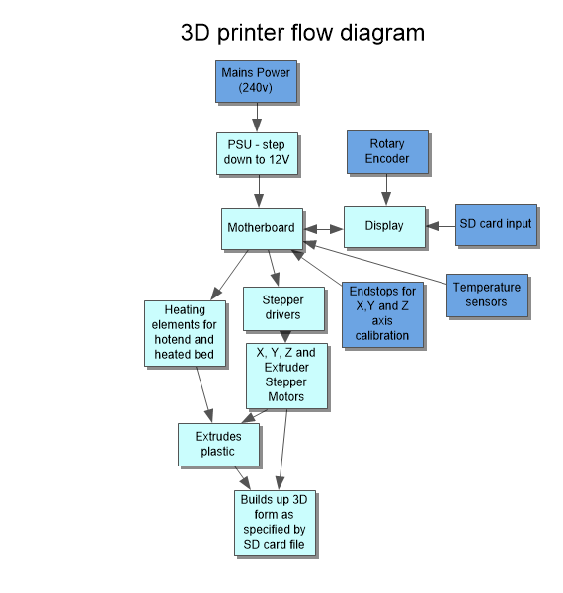

Arduino block diagram

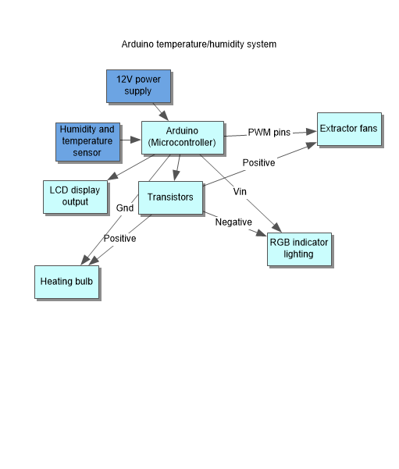

3d Printer block diagram

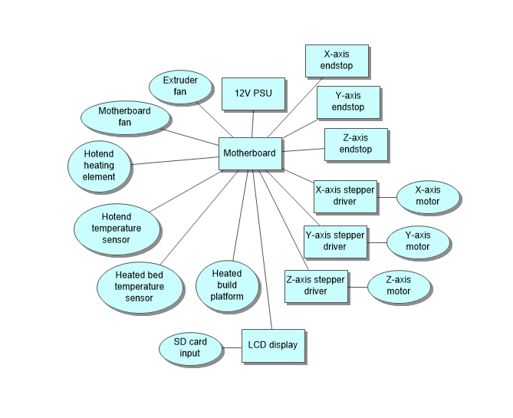

Research.

|  |  |
| --- | --- |
| D:\Users\MCC0021\AppData\Local\Microsoft\Windows\INetCache\Content.Word\Enclosed printer.jpg | This 3D printer is fully enclosed, with a glass door for the viewing and for the webcam. It’s large enough to still level the bed. Filament is running through a small hole that already existed in the back panel, and they are using a spare filament guide tube so nothing gets snagged.  The isolation from the environment around it allows for a greater range of materials to be used, while also creating a more stable and repeatable printing process, so therefore I will enclose my printer.  I also agree with the idea to leave the PSU outside the enclosure to prevent it from possible overheating.  This enclosure however, does not feature any means of actually controlling the environment inside it, only isolating it, and I would rather have some kind of temperature sensor inside it.  < https://makerhacks.com/ikea-3dprinter-enclosure/> 19th of July, 2017 |
| Featuring a sturdy metal frame, heated build plate, and also neatly routed wiring. The structure of this printer allows for extremely high quality prints, due to its rigidity and overall quality. The downside to this sturdy construction is the large amount of space it takes up, therefore decreasing its portability and also workability. While it looks somewhat complete, it doesn’t look like a final product, and could be aesthetically cleaner.  It also has no separation from the environment around it, which means it could potentially be inoperable in some environments.  I will attempt to incorporate as much stiffness as possible, through similar means to this, but also aim to create a more user friendly final product.  <http://www.instructables.com/id/Total-Metal-Hypercube-3D-Printer-no-Printed-Parts/> 19th of July, 2017 |  |
|  | Self-levelling and self-cleaning features are appealing, making for a simple user experience. Built with very high rigidity, without taking up a lot of space. It is a higher end machine (approx. $2500), and has very good feedback from buyers, so therefore the machines design must be fairly high quality. I like the cleanness of the wiring also the overall aesthetic, going with a simple colour theme of mainly black but also their own lime colour for printed parts. The heated bed here would also be a good design element to include in my 3D printer, allowing for more measured control over the temperature on the part, while also helping to stop warping.  < https://www.3dhubs.com/3d-printers/lulzbot-taz-6> 19th of July, 2017 |
| The geared feeder allows for easily swappable filament, but also extreme control over the extrusion of the nozzle  It has swappable nozzles which would be a good design feature for making different kind of parts.  The printer features optimized airflow, creating smoother prints where the fan caps ensure the airflow is aimed perfectly below the nozzle and equally from both sides.  I also like the clean wiring and simple user interface, with no more than necessary.  < https://ultimaker.com/en/products/ultimaker-2-plus> |  |
|  | The simple aesthetic of this printer just makes it look much better than other options. It uses quality metal materials, creating a sturdy product. They claim it is the most quiet printer ever made, using carbon fibre rods, so I will look into carbon fibre rods, or other bearings to find options that will keep my printer quiet. It also takes up a very small volume of space, and is easily transportable, being “the most space-efficient 3D printer ever made”.  Having a solid frame around all the sides would also make it easier to transport and move around.  <https://printm3d.com/themicro/> |
| This printer is built to need little to no maintenance as well as being very simple to use for people with no previous experience working with 3D printers.  Some of the pros of this printer include   * Wi-Fi printing * Fully automatic platform levelling and height sense * Power outage – resume print * HEPA filter to remove air-born contaminants * Filament sensor to automatically pause if it runs out   However, despite all of these positives, the consumer is forced to buy UP filament as it is the only type that will fit in the machine. I will attempt to include as many of the positives listed above to make my design as finished and easy to use as possible.  <http://3dprintingsystems.com/products/3d-printers/up-boxplus-3d-printer/> 20th of July, 2017 |  |

Component sourcing

|  |  |  |  |
| --- | --- | --- | --- |
| **Component** | **Option 1** | **Option 2** | **Option 3** |
| **Stepper Motors** | Nema17 -    4-wire bipolar stepper which has 1.8° per step for smooth motion and a decent holding torque. The motor has a max current of 350mA so that it could be driven easily with most motor drivers and a wall adapter or lead-acid battery. Some nice details include a ready-to-go cable and a machined drive shaft (easy to attach to).  <<https://www.adafruit.com/product/324>> 19th of July, 2017 | Hybrid Stepper –    High quality 2 phases hybrid stepper motor with 1.8°  Holding torque: 3.5kg/cm  Current: 1.7A/phase  Comes with 4 pin JST connector  It is a simple 2 phase hybrid stepper motor. It features 3.5kg high torque output. It can be applied into many situations and is commonly used in 3D printers and CNC machines.  <<http://www.robotshop.com/en/hybrid-stepper-motor-3d-printer.html>> 19th of July, 2017 | 60mm Nema17 –  D:\Users\MCC0021\Documents\_School\Systems\FOLIO\Research Images\Big motor.jpg  This is a custom Nema17 stepper motor with over 6.7kg/cm of holding torque, 1.5A rated current, a profile of 60mm and weighing around 470g. It is quiet, smooth running, and about as big as Nema17 motors come. It is perfect for medium/heavy duty CNC use.  <<http://www.ebay.com.au/itm/LearCNC-60mm-Nema17-Stepper-Motor-For-RAMPS-Prusa-Mendel-Rostock-3D-Printer-/201006654389>> 19th of July, 2017 |
| **Specifications/features** |  |  |  |
| **Price** | $14USD = Approx. $17.65AUD | $13.95USD = Approx. $17.59AUD | $24.95AUD |
| **Current/Phase** | 0.35A | 1.7A | 1.5A |
| **Holding torque** | 1.6kg/cm | 3.5kg/cm | 6.8kg/cm |
| **Rated voltage** | 12V | 3.4V | 12V |
| **Conclusion** | This motor is the easiest to setup, due to the low current and also the 12V rating which matches that of the power supply, meaning no more stepping down is needed. It also is reasonably cheap, but I will need 4-5 of them at least (one to two on the z axis, one on the x axis, one on the y axis and one for the extruder. | This motor is a much better torque rating and I would prefer to use it, however setting up the drivers, it would need to be a much lower voltage and might end up taking more setup. However it has the most appropriate level of torque from the three so I think it seems like the best option. | This is a very high quality motor, and has a very good torque rating, while also running on the standard 12 volts. It is also the most expensive of the lot, and buying 5 of them would be bad for my budget. Also while it does have a very high torque rating, it would most likely be unnecessary and just be a waste of money/power – this one uses 18W (12V\*1.5A), as compared to the others which use 4.2W (12V\*0.35) and 5.78W (3.4V\*1.7A). |
|  |  |  |  |
| **Stepper Motor Drivers** | A4988 -    Simple step and direction control interface Five different step resolutions: full-step, half-step, quarter-step, eighth-step, and sixteenth-step Adjustable current control allows you to set the maximum current output with a potentiometer,  which lets you use voltages above your stepper motor’s rated voltage to achieve higher step rates Intelligent chopping control that automatically selects the correct current decay mode  (fast decay or slow decay) Over-temperature thermal shutdown, under-voltage lockout, and crossover-current protection Short-to-ground and shorted-load protection  <http://www.ebay.com/itm/5PCS-A4988-Stepper-Motor-Driver-Module-3D-Printer-Polulu-StepStick-RAMPS-RepRap-/221921771439?hash=item33ab917faf:g:BpsAAOSwl9BWKyv1> 20th of July, 2017 | TB6560 -  Current level is automatically adjusted to required level. It uses a high speed light lotus root (microchip) to make sure it can deal with high speed stepping and not skip steps It has a thick heatsink to ensure good heat dissipation.  <http://www.ebay.com/itm/TB6560-3A-CNC-Router-Single-1-Axis-Controller-Stepper-Motor-Driver-Module-/191607025612?epid=896859271&hash=item2c9cab2fcc:g:oKgAAOSw4f5YCJRa>  20th of July, 2017 | DVR8825 –  D:\Users\MCC0021\AppData\Local\Microsoft\Windows\INetCache\Content.Word\stepper3.jpg  The module has a pinout and interface that are nearly identical to those of our A4988 stepper motor driver board, so it can be used as a higher-performance drop-in replacement for those boards in many applications. The DRV8825 features adjustable current limiting, overcurrent and over-temperature protection, and six micro-step resolutions (down to 1/32-step). It operates from 8.2 – 45 V and can deliver up to approximately 1.5 A per phase without a heat sink or forced air flow (rated for up to 2.2 A per coil with sufficient additional cooling).  <http://www.ebay.com/itm/Stepper-Motor-Driver-Module-DRV8825-for-3D-Printer-RepRap-4-RAMPS1-4-StepStick-/132117235089?epid=524699697&hash=item1ec2cd0591:g:ZWQAAOSw32lYvVMW>  20th of July, 2017 |
| **Specifications/features** |  |  |  |
| **Price** | $4.98USD = Approx. $6.29AUD  **For five drivers** | $4.68USD = Approx. $5.91  **For one driver** | $1.46USD = Approx. $1.84  **For one driver** |
| **Max Current Output** | 2A | 3A | 2.2A |
| **Operable Voltage** | 8 to 35V | 10 to 35V | 8.2 to 45V |
| **Overheating/Current protection** | Yes | Yes | Yes |
| **Under voltage lockout (UVLO)** | Yes | No | Yes |
| **Conclusion** | This is the cheapest option for five drivers, while also featuring all the necessary specifications for my build. While the current output is the lowest of the three, the high current shouldn’t be necessary for the needs of my printer, it will be relatively low weight, as it is using cheaper end components. | While having the best current output, these have a higher form factor, take up more space, and cost much more than the other two options. It also does not have under voltage lockout, making it more prone to stopping working. | While these are slightly more expensive than the first option, they have a better current output, and also a bigger range of voltage input, making them more tolerant to a variety of situations, so they would be better for possible modularity or change. |
|  |  |  |  |
| **Printer Control Board** | Ramps 1.4-  The modular design includes plug in stepper drivers and extruder controlling electronics, on the shield, allowing for upgrades and changes to the printer.  Ramps 1.4 uses the ATmega2560 as its core micro-controller development board, which has 54 digital I/O pins (14 pins that do PWM outputs), 16 sets of simulation on the input side, group 4 UARTs (hardware serial ports), using the 16 MHz crystal oscillator.  Development IDE interface (Arduino) is based on open-source principles, so I can modify and update as I wish.  The stepper motor drivers included are the A4988’s as shown previously, so it can drive up to 2A motors.  <http://www.ebay.com.au/itm/3D-Printer-Kit-RAMPS-1-4-Controller-Mega-2560-R3-Board-5pcs-A4988-NEW-/311894093862?epid=10002953685&hash=item489e563026:g:VcAAAOSwCkZZPl8z> 23rd of July, 2017 | Shanhai GT2560-  This includes all the same features as the Ramps 1.4, only all on one board, meaning it is more compact, and also simpler for setup. While pricier, it does have bonus features such as the heatsinks on the transistors, also making it more stable. It also does not include stepper drivers so I would have to buy my own, but they are not too expensive, so that would not be a major issue.  <http://www.ebay.com/itm/NEW-GT2560-Controller-Board-ATmega2560-for-Reprap-Prusa-Mendel-3D-Printer-/152097282464?epid=1756794017&hash=item2369b459a0:g:oAAAAOSwKfVXLCWU> 23rd of July, 2017 | Rumba-    This is a similar all in one solution, but also includes a screen and all the stepper drivers. The board has the most support (i.e. the highest number of peripherals), which allows for the highest amount of connections. This solution is well known and would be expected to just work out of the box no problems, so therefore would be a good option for ease of setup and ease of use later in production.  <http://www.ebay.com/itm/Geeetech-Rumba-ATmega2560-Reprap-Prusa-3D-printer-Control-board-A4988-LCD2004-/181751921243?epid=1368639805&hash=item2a51423a5b:g:anoAAOSw4DJYmm3L> 23rd of July, 2017 |
| **Specifications/features** |  |  |  |
| **Price** | $22.42 AUD | $47.89 AUD | $112.18 AUD |
| **Stepper Drivers included** | Yes | No | Yes |
| **LCD included** | No | No | Yes |
| **Fan included** | No | No | Yes |
| **CPU** | ATmega2560 | ATmega2560 | ATmega2560 |
| **Conclusion** | This option is by far the cheapest, however the component selection within the control board is not of the highest quality. It also has a bigger form factor with the double PCB layers, making it less space effective. | This option is a bit more expensive, however it would be much more reliable compared to the cheap Chinese board, allowing for a greater durability for the printer. I think this board is a good middle ground as I am able to buy reliable stepper drivers for not too much more. | This option is by far the most expensive and most likely out of budget for the project, however it includes all the necessary features so would be easy to setup and continue to run. While this would be good, the few extra features it presents for an extra $65 do not seem worthwhile, as it would be cheaper to buy these separately. |

Material Sourcing

|  |  |  |  |
| --- | --- | --- | --- |
| **Part** | **Option 1** | **Option 2** | **Option 3** |
| **Frame for enclosure** | 7mm Plywood-    Excellent face quality good for painting or staining. High bond strength. High strength capacity. Produced from plantation resources.  <https://www.bunnings.com.au/project-panel-1200-x-900-x-7mm-premium-grade-radiata-plywood\_p0390147> 8th of August, 2017 | Premade table -    Ease of assembly, pre-painted.  Low weight; easy to move. Low cost, requires minimal work.  <http://www.ikea.com/au/en/catalog/products/00352988/> 8th of August, 2017 | 16mm MDF-    Versatile, convenient and universal for indoor building products. Ideal for painting cutting, machining and drilling. Easy to use in good sizes. Excellent strength, with a uniform, smooth surface and edge.  <https://www.bunnings.com.au/11mm-standard-mdf-900mm-x-1200mm\_p0590041> 8th of August, 2017 |
| **Specifications/features** |  |  |  |
| **Price** | $21 | $7.99 | $18.16 |
| **Material** | Radiata Pine | Particleboard, Fibreboard, Acrylic paint, ABS, Paper, Foil | Radiata Pine |
| **Weight** | 4.9kg | 3.8kg | Unknown |
| **Conclusion** | The most expensive option, but would give the nicest look to the enclosure, with the natural grain of the wood. This would also be the strongest, as it is structural plywood, made for weight bearing etc. However this option is the most expensive and most likely unnecessary for the enclosure. | This is the easiest and cheapest option, I would virtually have to do nothing to this to complete the enclosure plus its low cost makes it a perfect choice for an enclosure. I would just have to find some scrap wood that I could use for the base, and then it would be a complete frame. | This is a much heavier option, but it would mean the enclosure would feel quite sturdy, while also being easier to machine than the plywood, no joints having to be machined. It is also only a few dollars cheaper than the plywood, but over double that of the table. |
|  |  |  |  |
| **Window/door panels** | 3mm Clear Acrylic-    Inherently UV resistant. Stronger and more flexible than glass. Lighter than glass. Easily worked, formed and fabricated.  <https://www.bunnings.com.au/ssuntu-900-x-600-x-3mm-clear-acrylic-sheet\_p1010496> 8th of August, 2017 | 12mm Glass-    Safety glass, Australian standards compliant. 20 year warranty.  <https://www.bunnings.com.au/everton-960-x-650-x-12mm-glass-balustrade-panel\_p1142312> 8th of August, 2017 | 2.7mm Plywood-    Premium grade radiate face, suitable for painting and staining. Produced from plantation pine resources.  <https://www.bunnings.com.au/project-panel-1200-x-810-x-2-7mm-premium-bc-plywood\_p0340268> 8th of August, 2017 |
| **Specifications/features** |  |  |  |
| **Price** | $55 | $54 | $11 |
| **Weight** | 1kg | 19.4kg | 1.7kg |
| **Conclusion** | This option is while the most expensive, also strong, flexible and easily machinable while still looking almost as good as glass. It also is UV resistant, which is good for a 3D printer as plastics are often somewhat UV sensitive. | This option would provide an amazing finished look to the piece, however, it is just too heavy, and also would be very hard to machine, so is therefore not worth buying for the enclosure. | This is the clear winner when it comes to price, however it almost seems necessary to be able to see into the printer while it is printing so that is why I think the acrylic is the best option. |
|  |  |  |  |
| **Plastic for printer** | PLA-    Poly-Lactic Acid is a thermoplastic that prints best at approximately 210°. PLA has a much less tendency to warp compared to ABS, therefore it is not necessary to have a heated bed.  <https://www.3dprintergear.com.au/filaform-select/240-black-pla-filament-1kg-22lbs.html> 8th of August, 2017 | ABS-    Acrylonitrile Butadiene Styrene, is a thermoplastic, produced from fossil fuels, is not biodegradable, and has a worse environmental impact than PLA. It is however stronger and more rigid than PLA.  <https://www.3dprintergear.com.au/filaform-select/239-black-abs-1kg-22lbs.html> 8th of August, 2017 | PET-G-    Polyethylene Terephthalate Glycol, is high strength and resistant to chemicals. Zero odours and is transparent. It offers high tensile strength and low elongation.  <https://www.3dprintergear.com.au/co-polymers/506-taulman-tech-g-1-kg-22-lbs.html?search\_query=petg&resresr=3> 8th of August, 2017 |
| **Specifications/features** |  |  |  |
| **Cost** | $26.95 | $26.95 | $39.96 |
| **Biodegradable** | Yes | No | No |
| **Print temperatures** | 190-220°C | 230-250°C | 235-245°C |
| **Bed temperatures** | 40-50°C | 80-110°C | 40-50°C |
| **Weight** | 1kg | 1kg | 1kg |
| **Conclusion** | The easiest to print, low temperature as well as the only option that is biodegradable. While maybe not as strong as the two other materials this would be the best in terms of ease of use and also sustainability, but also, doesn’t require ventilation to get rid of bad fumes. | This material is very strong, however it is known to warp significantly, so the parts may not come out as nicely as with PLA or PET-G. It is also known to produce potentially harmful fumes, so the extra need for ventilation is a negative factor. The temperature it prints at also is an unfortunate necessity, possibly degrading the nozzle over time. | PET is a very common plastic. While for this it may seem like a good option, I think just the fact that it is not biodegradable is enough of a reason to not buy it. However, it is odourless, and also has a high tensile strength, while also being chemical resistant. It seems like a decent option, but due to it being a consumable I think it is better to go with the more economical and environmentally sustainable option; PLA. |

Design Ideation.

**Option 1 –**

Simple wooden frame, transparent door and side panels. Solid base plate for mounting. Simple spool holder above enclosure.

**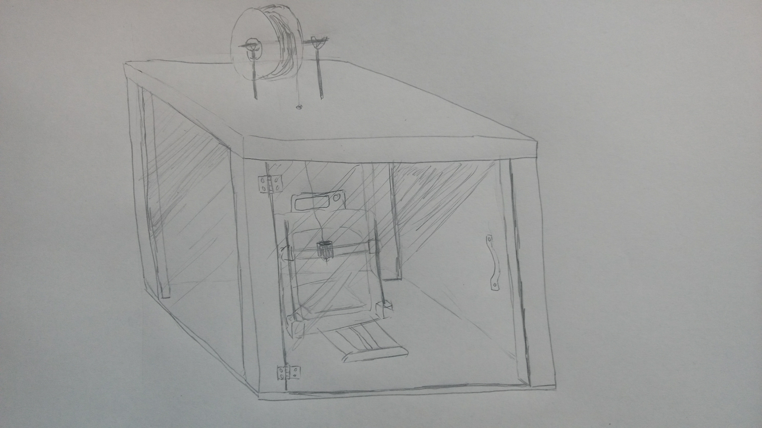**

**Option 2 –**

Big angular front door panel, cut from plywood. Simple spool holder above enclosure. Transparent viewing window on the side, printer is also facing the direction of the window. Extractor fan mounted on the back panel.

**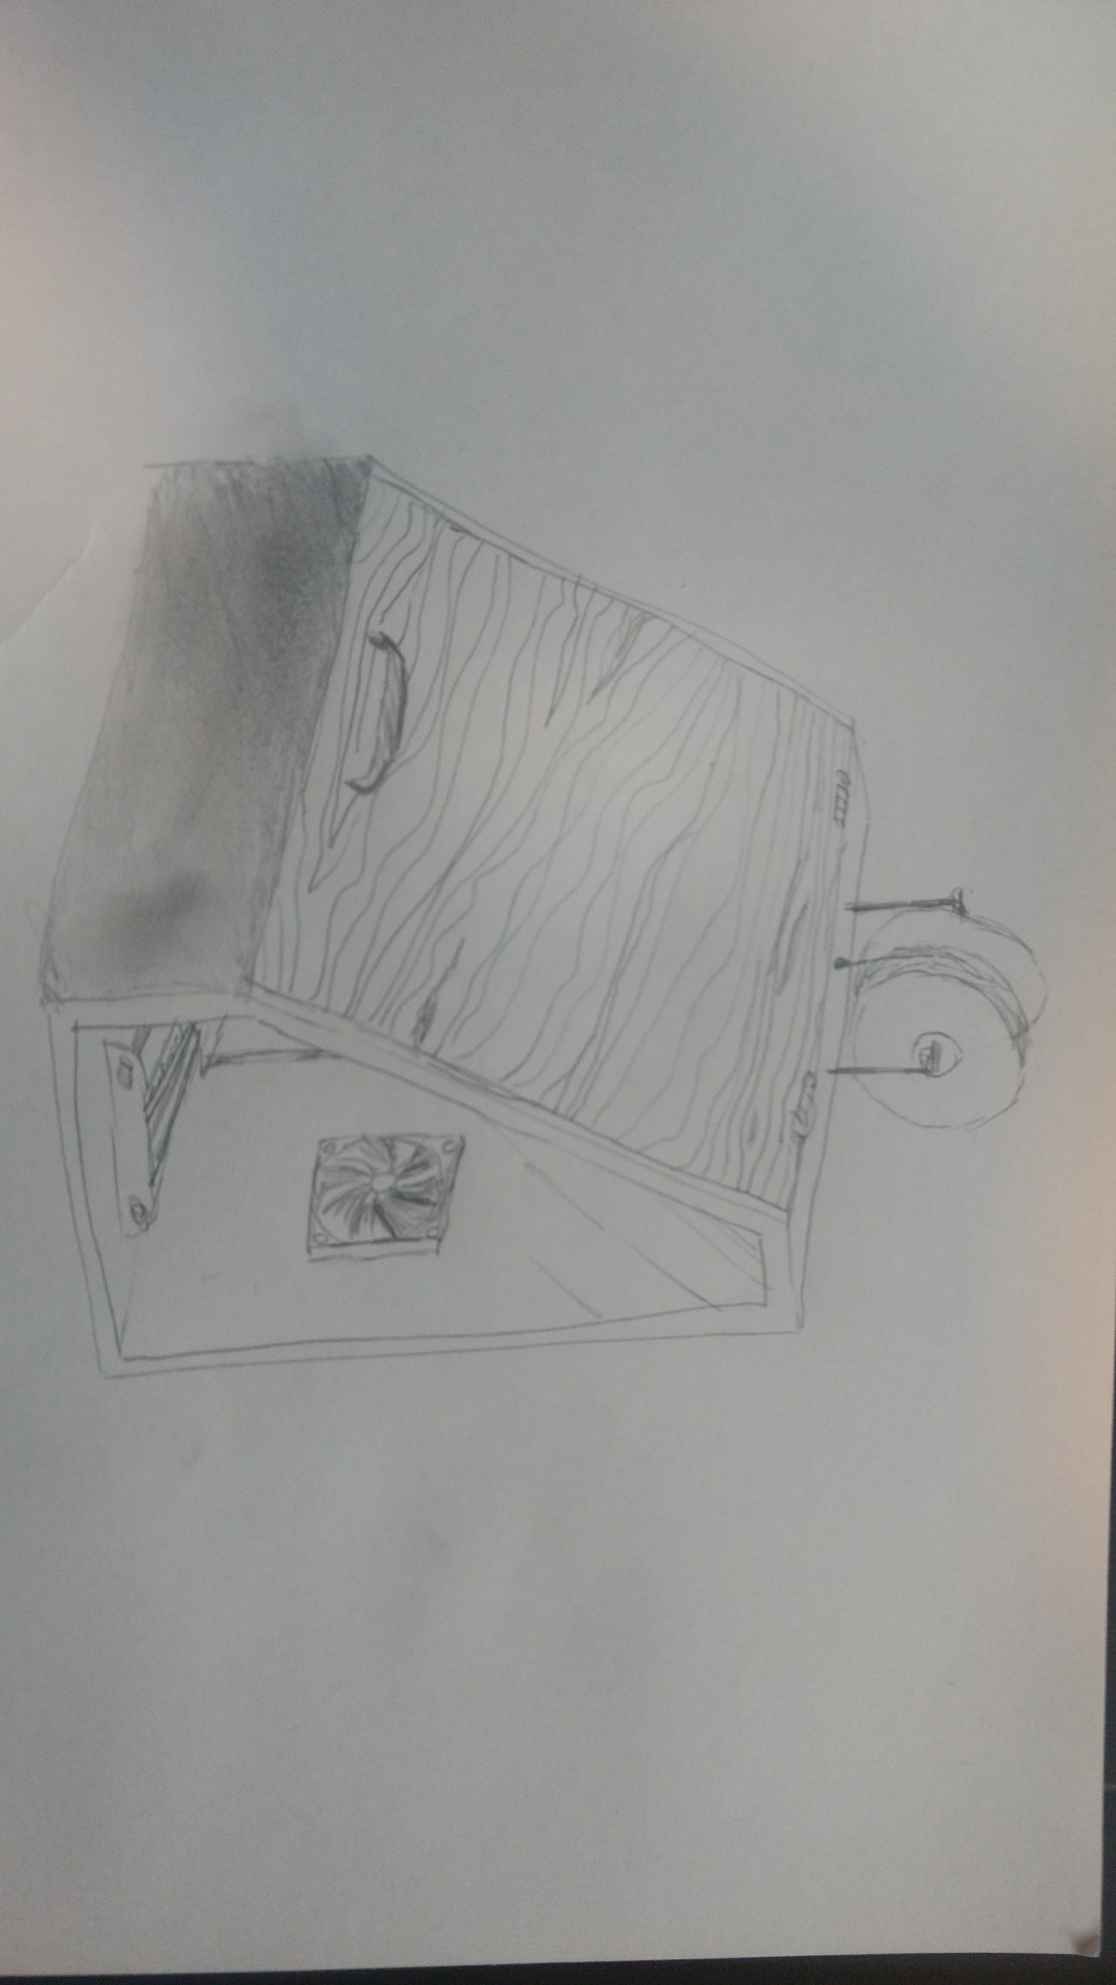**

**Option 3 –**

Metal T-slot framing connected by angular brackets, plywood panels, small acrylic door on front panel, using magnets to hold the door shut. Spool holder attached on side panel, filament can be run through the back panel.

**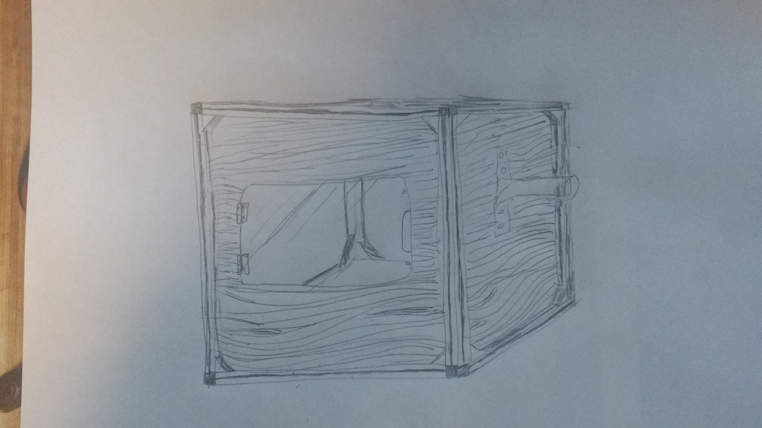**

Final Design.

3D printer model inside enclosure, as similar in dimensions as possible to my 3D printer, sourced from < https://grabcad.com> 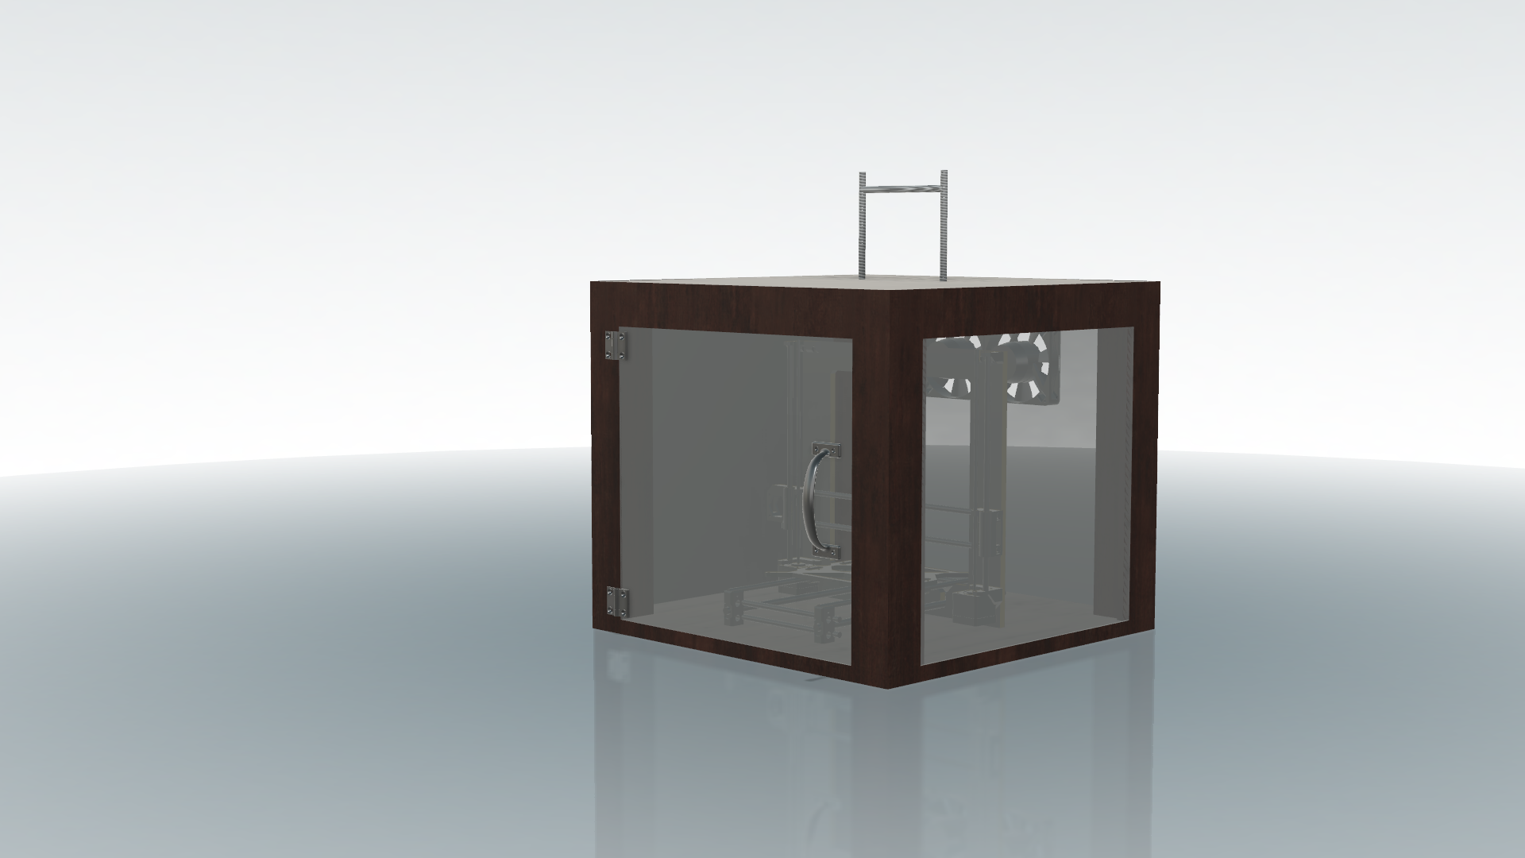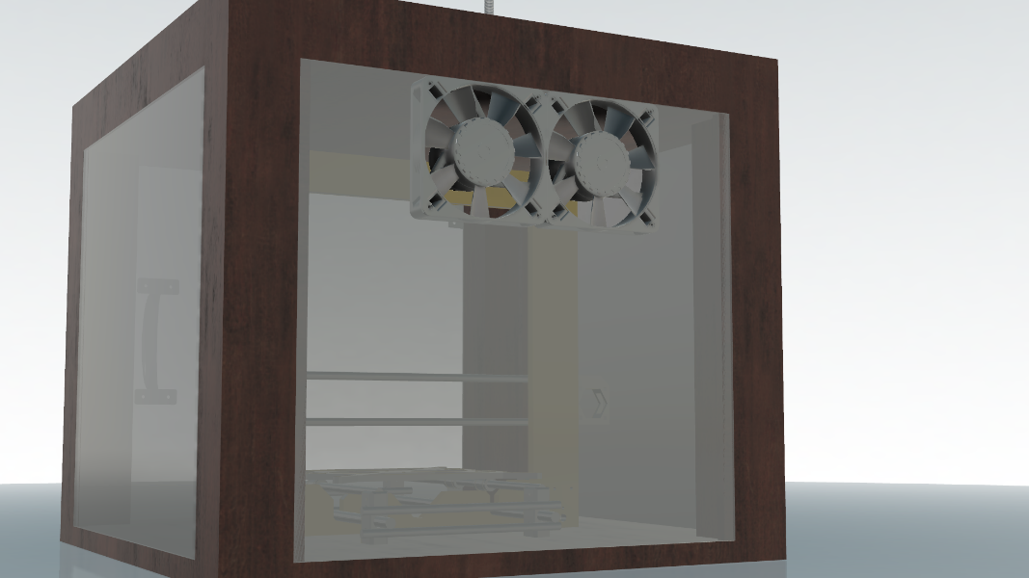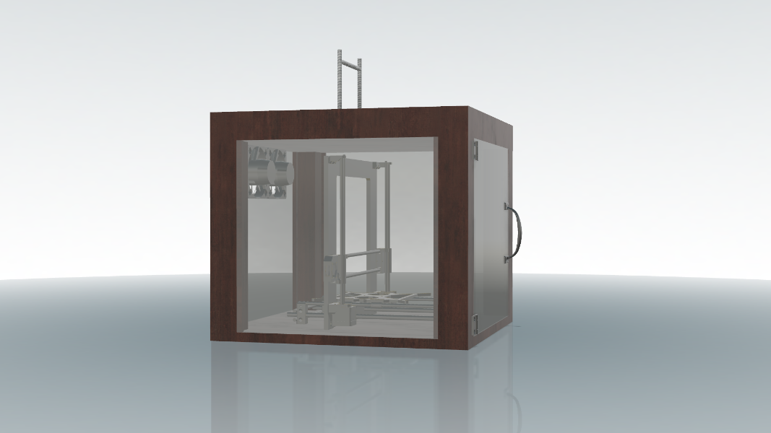

I decided to follow many of the design features from my option number one, the wooden frame being the simplest to create, while also being the cheapest to produce, as compared to the t-slot aluminium frame. I decided to also incorporate two fans (like in option two) as these should help with airflow and temperature regulation. It uses two small hinges for simplicity plus a handle to make it easy to open. The threaded rod on the top of the enclosure is to act as a spool holder. If I use small strips of wood on the edges of the frame (as in picture), I can flush mount the acrylic to the outside, giving a nice clean look to the enclosure.

Working Drawings.

Circuit Design

**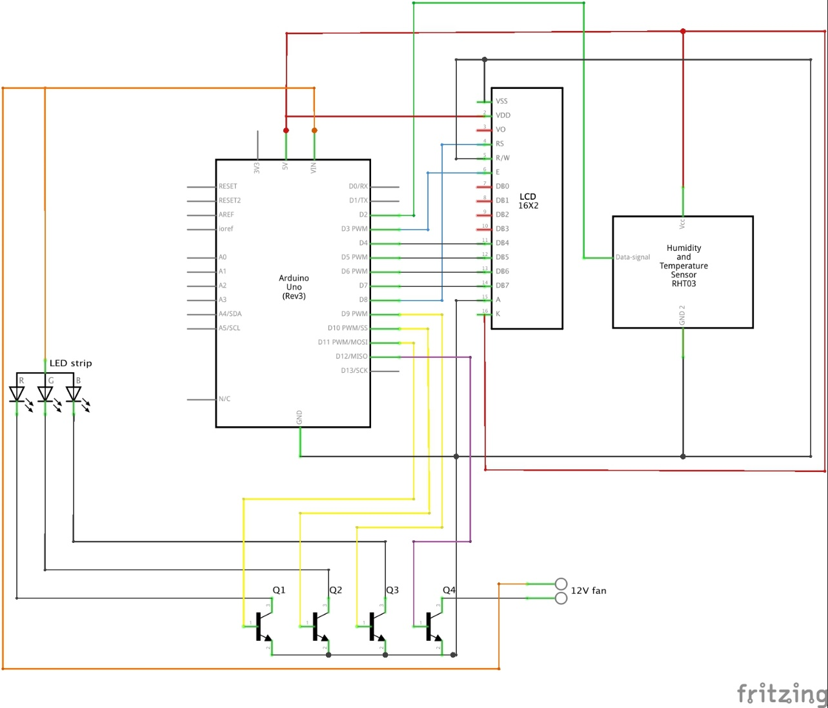**

I designed this circuit using the program called “fritzing”, to connect all of my components to the Arduino. I researched all the individual components to see what was necessary to connect them.

Basically the transistors (labelled Q1-4) act as gates for the LEDs and fan, using the low current, 5V output of the Arduino pins to complete the 12V circuit of the LEDs and fan, therefore turning them on. They are delivered 12V as the Arduino is plugged into a 12V power supply which is regulated by the Arduino to 5V, however is still accessible through the VIN (voltage in) pin. The three led transistors are plugged into PWM pins on the Arduino which just allows for control such as dimming and fading of the lights. The LCD screen is wired up according to is specifications, and the only important connection was that the E (enable – tells the LCD when data is ready for writing) pin be plugged into PWM, the rest of them are interchangeable as long as you update the code to match them. The humidity sensor is very easy to connect, only requiring one data pin, to any terminal on the Arduino, and then just the appropriate 5V and GND connections.

Enclosure

Working drawings for my chosen enclosure

**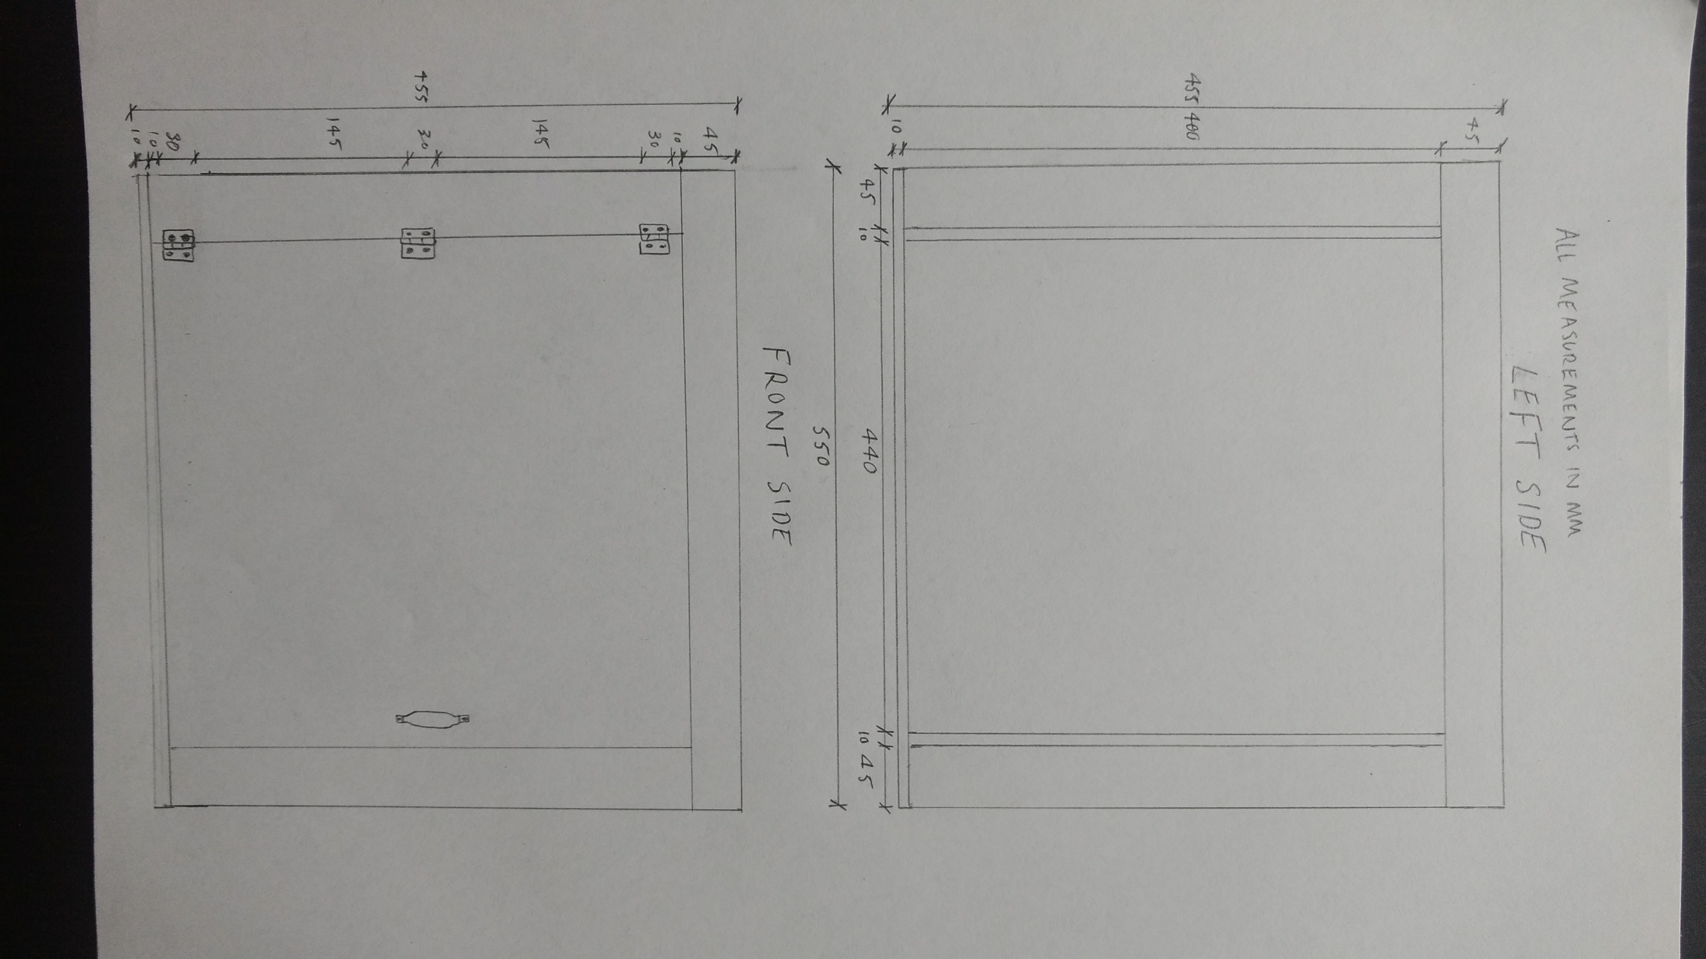**

Extruder

Main body redesign. Left top screw acts as a pivot for the whole design, allowing the “top part” to freely move around its axis. A spring is then inserted between the two 8mm hemispheres, acting as a tensioner. 21/06/17 **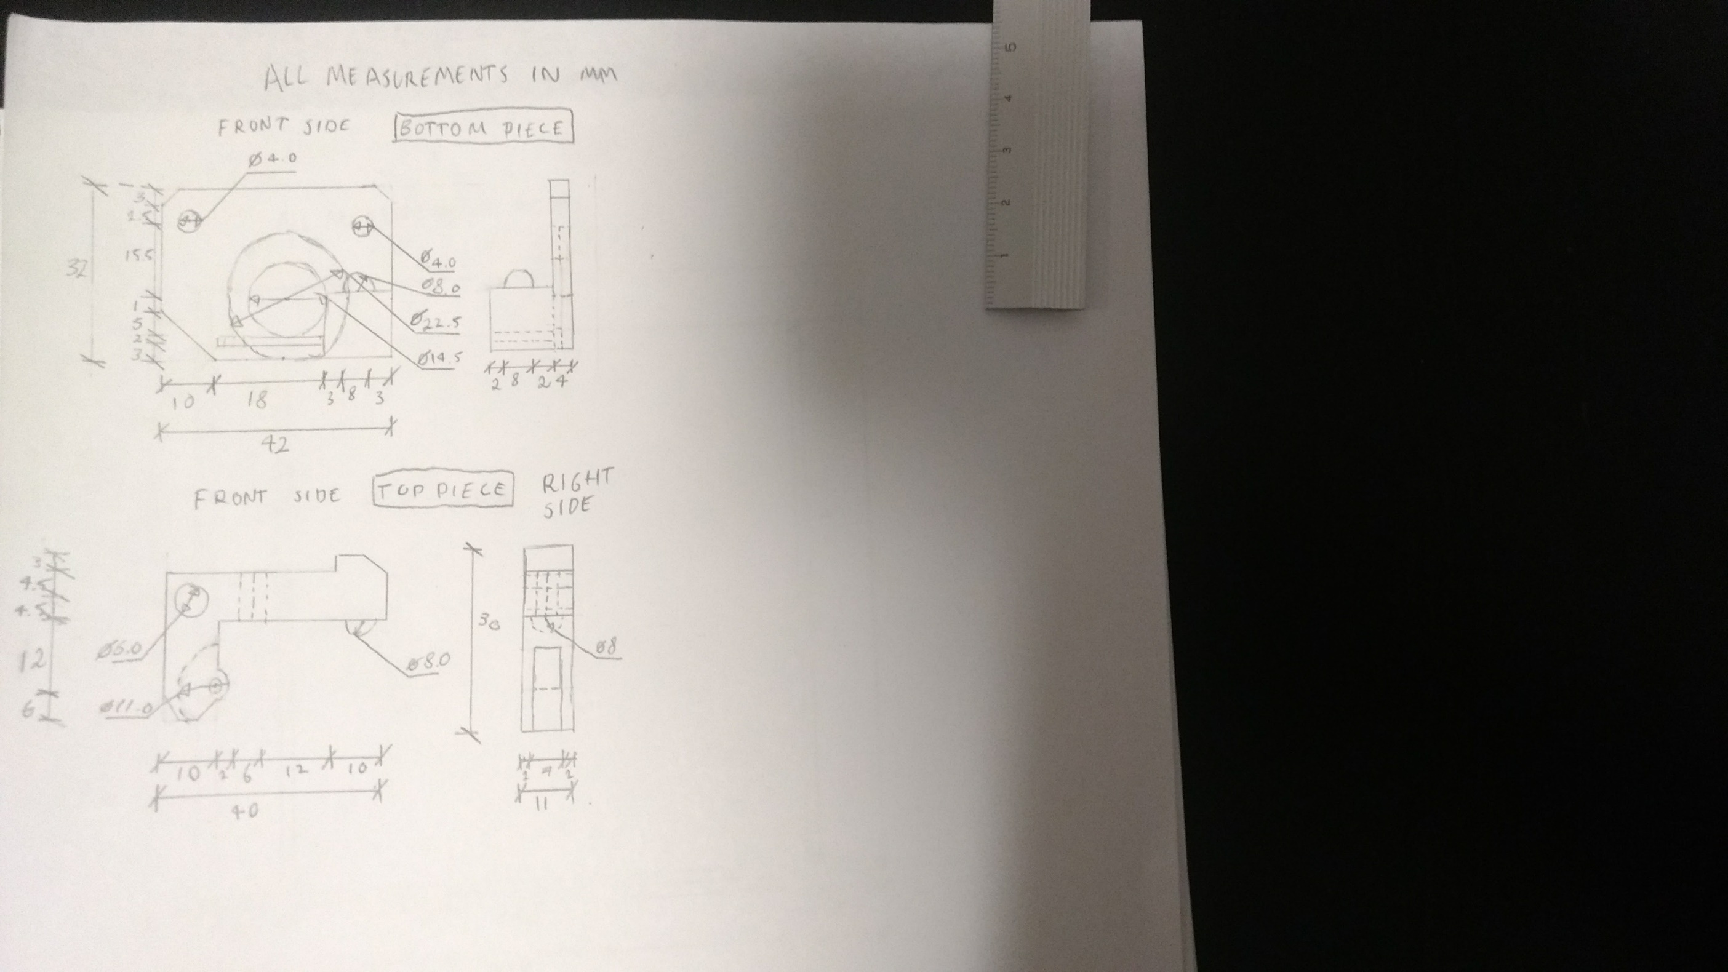**

This part is designed to let me use the stronger, metal extruder arm, acting as an adapter giving more space for the gear system. 07/08/17

**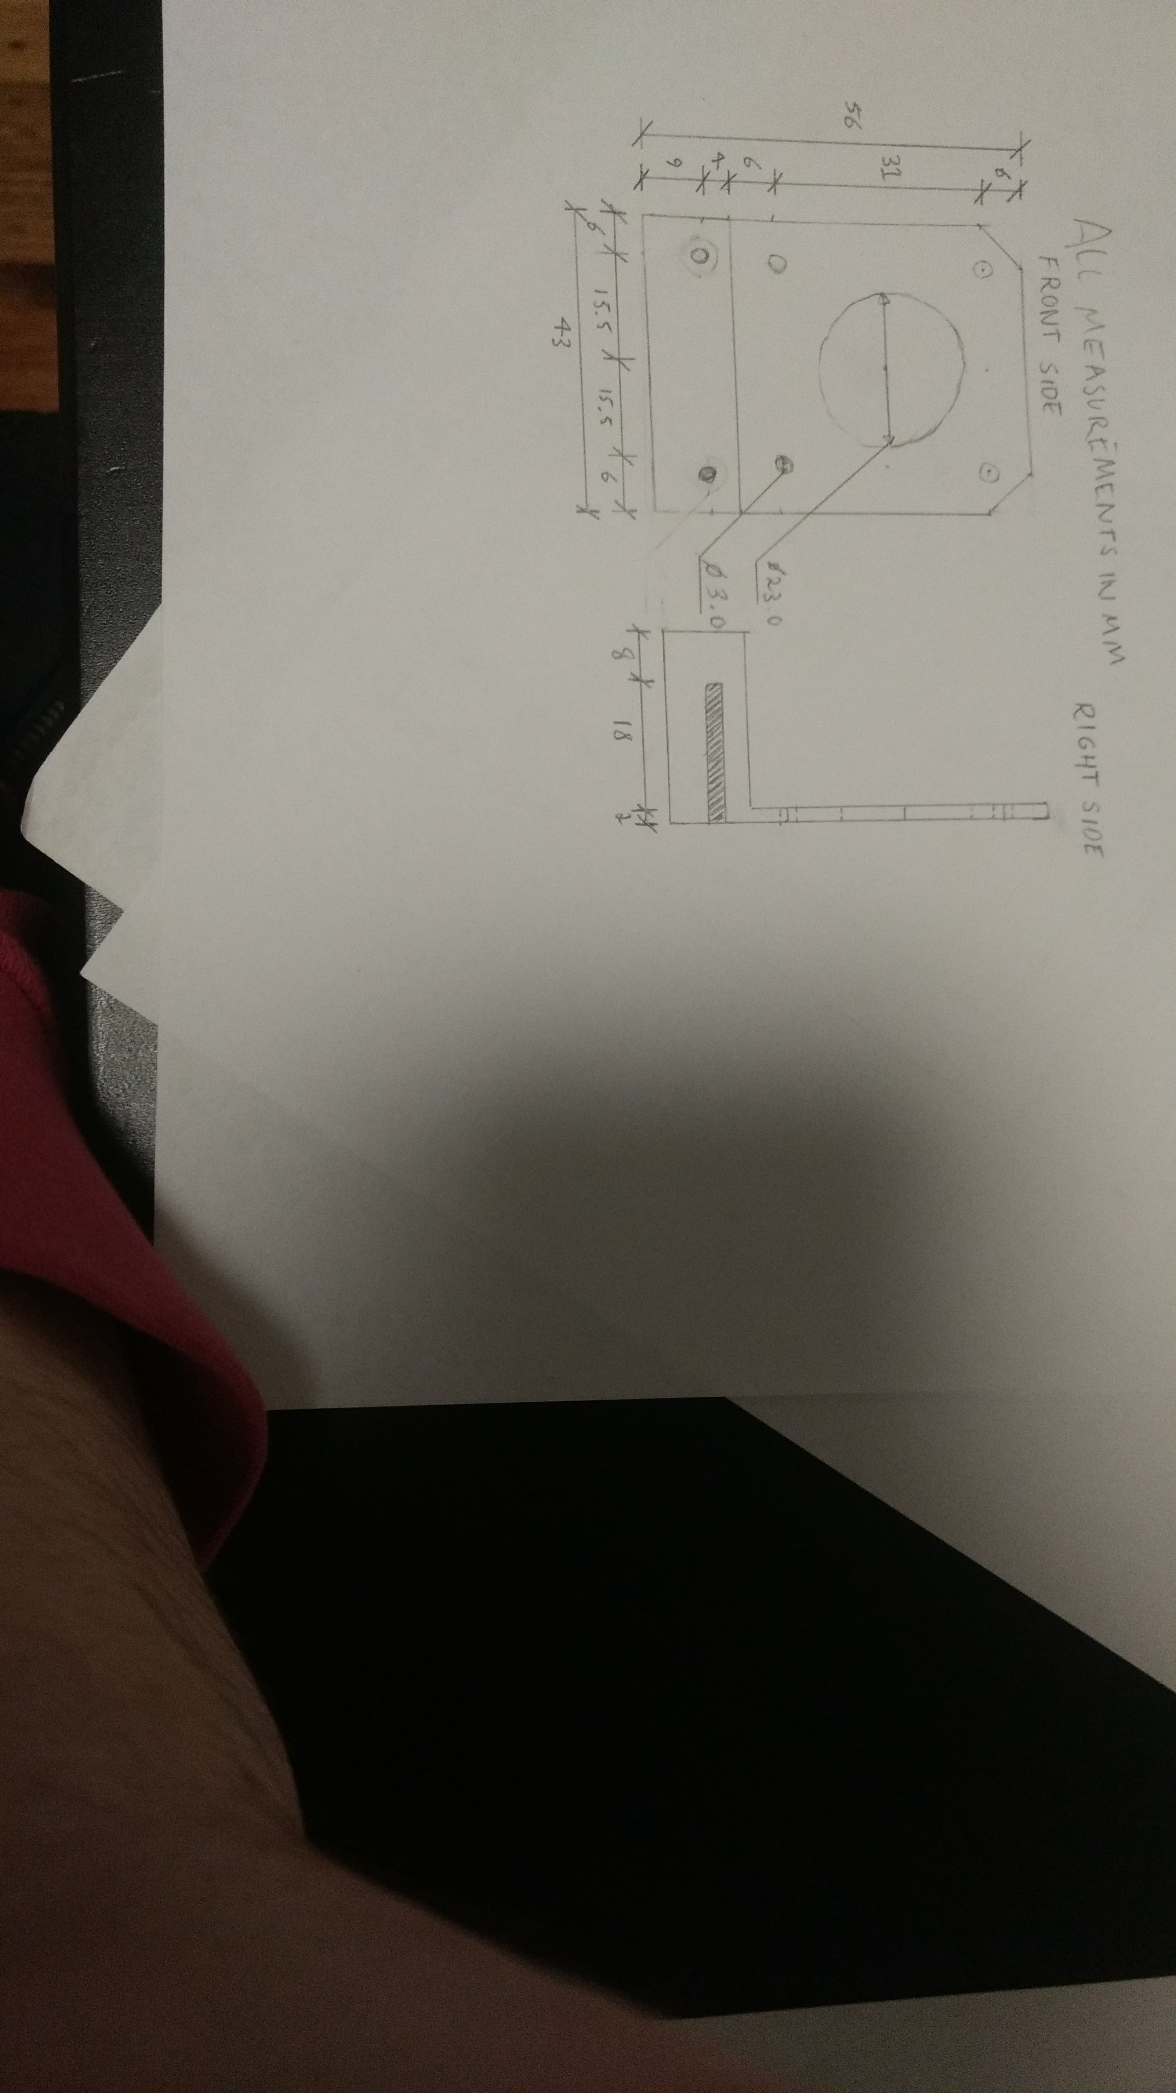**

Fan mount/duct V2

This is the first redesign from scratch of my fan duct system, I have given it a much bigger area for attachment to the plate, also changing the orientation of the fan mount, so that it mounts to the side, therefore not crashing into the beam of the printer. It has a more smoothly curved airflow duct too. 14/08/17

**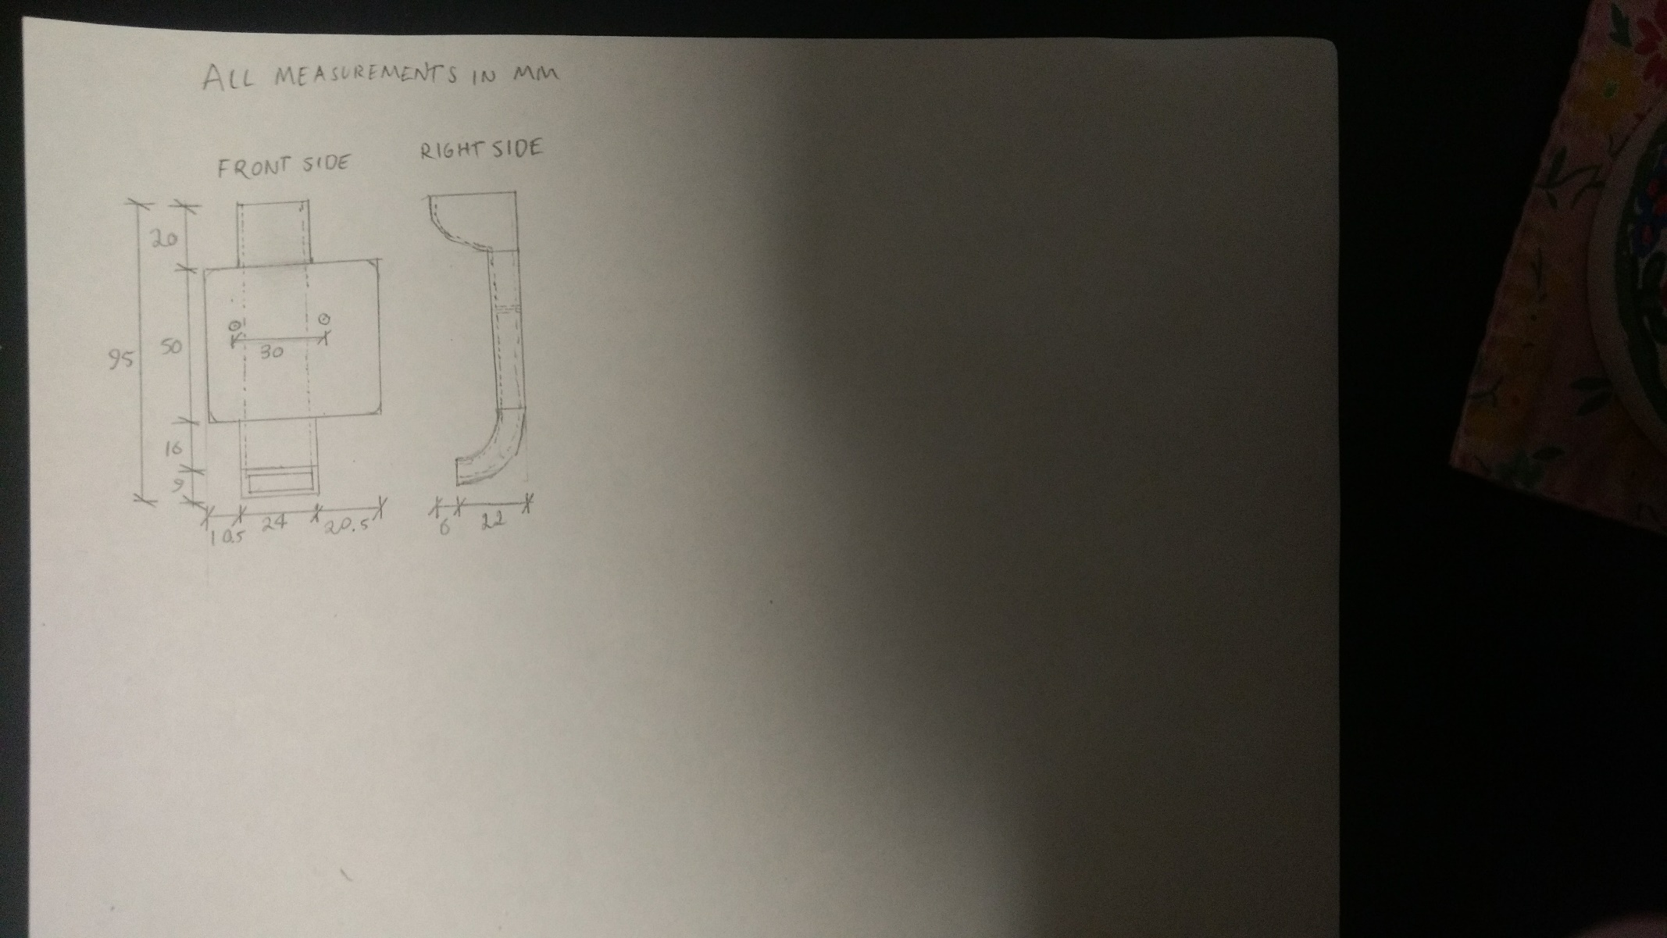**

E3D V6 Hotend mount

This is my mount for the bowden style print head. Has a square duct hole for later attaching the fan and main pipe that directs the air. 20/07/17

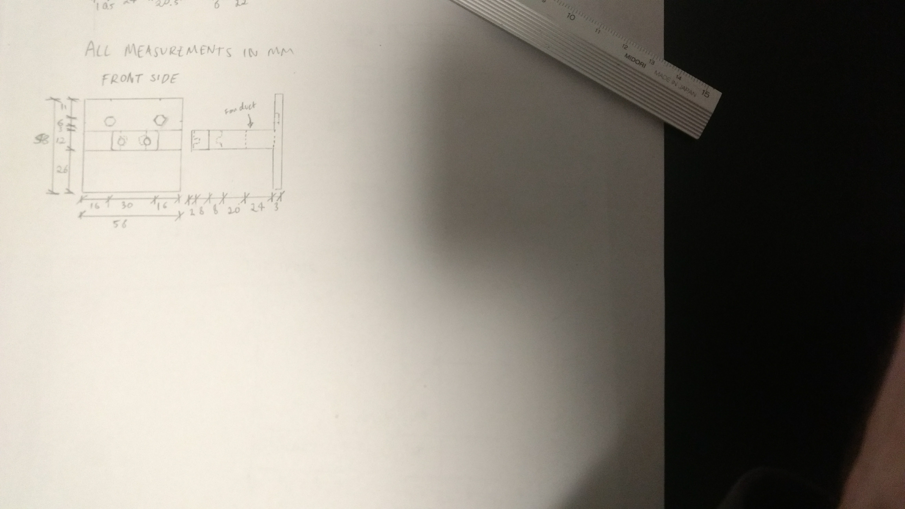

Parts/tools list.

|  |  |  |  |  |  |
| --- | --- | --- | --- | --- | --- |
| Description | Material and Colour | Overall Dimensions | Cost (ea) | Qty | Total Cost |
| Ikea Lack Table for enclosure frame | Particleboard & Fibreboard (Black) | 550 x 550 x 450 | $7.99 | 1 | $7.99 |
| Window panels | Acrylic (Clear) | 900 x 600 x 3 | $55 | 1 | $55 |
| 1kg plastic | PLA (Black) | 200 x 200 x 78 | $26.95 | 1 | $26.95 |
| Printer frame | Plywood (Pine) | 1200 x 810 x 2.7 | $11 | 1 | $11 |

|  |  |  |  |  |  |
| --- | --- | --- | --- | --- | --- |
| Description | Supplier | Size | Cost (ea) | Qty | Total Cost |
| Nema17 Stepper Motor | [Robot](http://www.robotshop.com/en/hybrid-stepper-motor-3d-printer.html)Shop | 42 x 42 x 40 | $17.65 | 5 | $88.25 |
| Stepper Driver A4988 (5pcs) | King Electronics | 15 x 20 | $6.31 | 1 | $6.31 |
| Shanhai Mainboard | Pancychan | 107.3 x 78.7 | $50.79 | 1 | $50.79 |
| Mk6 Extruder assembly | 3DP | 50x100x255 | $30.56 | 1 | $30.56 |
| 50mm M3 screws | Bunnings | 50x3 | $0.54 | 25 | $13.50 |
| 25mm M3 screws | Bunnings | 25x3 | $0.18 | 50 | $9.16 |
| M3 nuts | Bunnings | 5x5x2 | $0.13 | 100 | $13.00 |
| Linear bearings | eBay | 18x18x36 | $2.55 | 6 | $15.30 |
| M3 wing nuts | Bunnings | 10x10.4x21.4 | $0.39 | 6 | $2.31 |
| Heated build plate | eBay | 214x214 | $9.93 | 1 | $9.93 |
| Smooth rods | eBay | 285x8x8 | $3.15 | 6 | $18.90 |
| Threaded rods | eBay | 290x8x8 | $4.95 | 2 | $9.90 |
| M3 washers | Bunnings | 9.5x0.95x9.5 | $0.13 | 100 | $12.70 |
| Endstops | eBay | 20x14x6.7 | $1.80 | 3 | $5.50 |
| Plastic gear (PITCH) |  |  | $0.60 | 2 | $1.20 |
| Idler gear (PITCH) |  |  | $0.73 | 2 | $1.46 |
| Timing belt (PITCH) | eBay |  | $1.17 | 2 | $2.34 |
| Zip-ties | Selby acoustics | 3.6x300 | $0.033 | 100 | $3.30 |
| Power supply (12V x 20A) | eBay | 41x90 | $34.85 | 1 | $34.85 |
| Axial fan | Sourced from old computer | 120x120x5 |  | 2 |  |
| Centrifugal fan | eBay | 50x15 | $8.85 | 1 | $8.85 |
| Nylon standoffs | FPVfaster | 9.5x9.5 | $0.25 | 6 | $1.50 |
| Power supply switch | eBay | 15x10 | $1.05 | 1 | $1.05 |
| Z-axis threaded rod | eBay | 8x400 | $7.37 | 2 | $7.37 |
| Plastic coupler | eBay | 6x20 | $0.34 | 2 | $0.68 |
| LCD for printer | eBay |  | $12.91 | 1 | $12.91 |
| Borosilicate glass | eBay | 200x200x3 | $9.72 | 1 | $9.72 |
| Binder clips | Kmart | 19 | $0.07 | 4 | $0.30 |
| Cable tidy | EBay |  | $4.71 | 1 | $4.71 |
| Hinges | Bunnings |  | $1.03 | 3 | $3.09s |
| Handle | Bunnings |  |  | 1 |  |
| Sponge |  |  |  | 1 |  |
| Arduino |  |  |  | 1 |  |
| Temperature/Humidity sensor | Jaycar |  | $29.59 | 1 | $29.59 |
| 16x2 LCD for Arduino | Jaycar |  |  | 1 |  |
| RGB LED strip |  |  |  | 1 |  |
| Jumper wires | Jaycar |  |  | 50 |  |
| Transistors | Jaycar |  |  | 4 |  |
| PC fans |  |  |  | 2 |  |

Production plan.

Steps

|  |  |
| --- | --- |
|  | **Order/buy all of the components and parts** for the build |
|  | **Cut plywood for frame**, using the school laser cutter, cutting the main frame parts for a Prusa i3 printer (found online), out of 2.7mm plywood from the SVG files |
|  | **Print parts,** using the school printer, print all the Prusa i3 clone 3d printer parts (found online) |
|  | Assembly of **z-axis motors housing** – use the required screws to mount them to the plywood |
|  | **Y-carriage assembly** – start by zip-tying the four bearings to the plywood plane |
|  | Using four m3 screws, and wing nuts, wedging springs between the two plates, attach the heated build plate |
|  | Slide two smooth rods through the bearing on the underside of the bed |
|  | Using the plywood y-carriage pieces as ends for the assembly, pass through two of the threaded rods through the lower holes in the plywood, while also putting washers and nuts on either side of each plywood piece, also sliding the smooth rods in-between |
|  | Screw the endstop onto the side of the plywood, on the side of the bed where the text is facing down |
|  | Attach a stepper motor to the same end, using its mounting plate, also fixing a plastic gear to the shaft, on the other end, the idler gear can be attached with the printed holder for it in the square hole for it |
|  | The timing belt must then be strung around both gears, and through the bottom of the build platform, tying it off with relatively high tension, but then tightening it further with the screw attached to the idler gear |
|  | **X-carriage assembly –** The first step is to screw down the two nuts that attach to the z-axis threaded rod, these use four short m3 screws, and are attached to the two printed end cap x axis parts. |
|  | Next you must place the bearings in the cylindrical slots, using longer m3 screws to clamp them inside |
|  | A motor can now be attached to the biggest part of the assembly, attaching with three m3 screws, also attach a gear to the shaft of the motor |
|  | The idler gear can be attached to the other end cap, using the printed piece to hold it in place |
|  | Now with the flat printed piece, zip-tie the two bearings in place, and then slide two smooth rods through these bearings |
|  | The end caps can now be attached to each end of these two rods, making sure that their orientation is correct with the z axis nuts on the bottom |
|  | Run the timing belt around the two gears, tying off the two ends with zip-ties around themselves over their set places on the middle sliding part of the assembly |
|  | Screw the endstop onto the same part that the motor is attached to, into the two screw holes on the top of the part |
|  | **Frame –** using m3 screws and nuts, holster the main square plate of the frame to the two triangular supports |
|  | Attach the **power supply** to the right support, which has the cut-out ventilation for the power supply |
|  | Attach the **motherboard fan** to the panel where the holes are placed for it, using the small nylon standoffs for spacing |
|  | **Wiring the power supply –** Attach the switch with two m3 screws and nuts to its cut-out on the same support as the power supply |
|  | Now the three wires have to run out through the wiring hole to the three screw terminals on the power supply in order from right to left, neutral (black), live (red), earth (green and yellow) |
|  | **Attaching the bed –** to attach the bed assembly, you hook the threaded rod into the slot on the main frame of the printer, screwing two m3 screws from each rod to the frame for stability |
|  | **Z-axis motors –** attach the two z-axis motors to the left and right sides of the frame in their assembled state, using three m3 screws and nuts, screw on the z endstop to the left motor, making sure it lines up with the vertical adjustment screw on the x-carriage |
|  | **Motherboard mounting –** The motherboard is attached to the opposite side as the power supply, using four standoffs and screws |
|  | **Attaching the X-carriage –** firstly begin by attaching the two z-axis threaded rods to the z-axis motors using plastic couplings which are friction fit to the shaft as well as the small end of the threaded rods |
|  | Now placing the x-carriage assembly at the top of these two rods, lining up the nuts, begin turning the two threaded rods anti clockwise until the assembly is substantially attached |
|  | Slide the two remaining smooth rods through the bearings on the x-carriage, and lining them up into their cut-out holes on the motors at the bottom |
|  | Now screw on the z-axis caps to the top of the frame, holding the smooth rod in place |
|  | **Screen mounting –** Attach the screen assembly to the top of the frame with two m3 screws and nuts |
|  | **Extruder –** The extruder needs to be attached through the two screws to the back of its mount, making sure it is fairly tight so as little unwanted movement is allowed as possible |
|  | **Borosilicate glass –** the glass bed is placed on top of the heated plate, and using four small binder clips attached securely |
|  | **Wiring –** The five stepper motors are plugged into the board below the stepper drivers, in the appropriate axis plugs, the z motors plugged in parallel to the single driver |
|  | The motherboard’s power connection has two black and two red wires which screw into the two ground and 12V plugs on the power supply respectively |
|  | The three axis endstops plug into the endstop sockets for their axis on the right hand side of the motherboard |
|  | The extruder and motherboard fans plug into the fan sockets in the bottom corner of the motherboard |
|  | The heated bed and nozzle heating element plug into the green plugs at the top of the board |
|  | The thermistor on the bed and nozzle for measuring temperatures plug into the sockets on the right of the board |
|  | The two LCD ribbon cables plug into their rectangle plugs in the right/centre of the board, running to the LCD around the back of the machine |
|  | All the wires from the extruder assembly can be wrapped with a cable tidy, to make sure none of those wires get caught on any moving parts |
|  | **Enclosure –** Start by assembling Ikea Lack side-table |
|  | Grooves must be cut into the legs to accommodate the acrylic panels for three out of four sides, marking which sides of the legs are to be cut before removing them, then cutting grooves with the table saw, setting the distance at half the width of the legs, and the depth of the cut at just a few millimetres |
|  | The next step is to cut the full length of acrylic 400mm wide (the depth of the table) again using the table saw. The required lengths can then be cut (using a scroll saw) depending on how wide the gaps between the legs are (some deviation expected per side, due to the cheap nature of the table) |
|  | The acrylic pieces are slid into the grooves of the table, and then a scrap piece of wood can be used for the base (measuring 550x550) screwed into the bottom of the table with self-tapping screws |
|  | One more acrylic window will be cut, but for the door, so must be very accurate, I will use three hinges on the left side of this piece, and mount a small handle on the opposite side |
|  | The filament will have to be outside the enclosure so I will drill a small hole through the enclosure to pass through the filament, and also add a dust filter to the entry point to clean the filament as it is fed in |
|  | **Arduino temperature/humidity system –** The first step is to wire up an Arduino as specified in my design document |
|  | Writing the control program for the Arduino |
|  | The RGB LEDs can be mounted to the roof of the enclosure/table, facing downwards providing the light for the printer, the temperature/humidity sensor can be mounted also in a similar location |
|  | Two squares can be cut out of the back of the acrylic panel to hold two fans controlled by the Arduino, to extract hot air, these can be mounted with small m3 screws in the corners |
|  | Testing print quality – comparing different settings |

GANTT chart **(production phase)**

|  |  |  |  |  |  |  |  |  |  |  |  |  |  |  |  |  |  |  |  |  |  |  |
| --- | --- | --- | --- | --- | --- | --- | --- | --- | --- | --- | --- | --- | --- | --- | --- | --- | --- | --- | --- | --- | --- | --- |
| **Step** | **Week Est. Act.** | | | | | | | | | | | | | | | | | | | | | |
|  | **01** | **02** | **03** | **04** | **05** | **06** | **07** | **08** | **09** | **10** | **11** | **12** | **13** | **14** | **15** | **16** | **17** | **18** | **19** | **20** | **21** | **22** |
|  |  |  |  |  |  |  |  |  |  |  |  |  |  |  |  |  |  |  |  |  |  |  |
|  |  |  |  |  |  |  |  |  |  |  |  |  |  |  |  |  |  |  |  |  |  |  |
|  |  |  |  |  |  |  |  |  |  |  |  |  |  |  |  |  |  |  |  |  |  |  |
|  |  |  |  |  |  |  |  |  |  |  |  |  |  |  |  |  |  |  |  |  |  |  |
|  |  |  |  |  |  |  |  |  |  |  |  |  |  |  |  |  |  |  |  |  |  |  |
|  |  |  |  |  |  |  |  |  |  |  |  |  |  |  |  |  |  |  |  |  |  |  |
|  |  |  |  |  |  |  |  |  |  |  |  |  |  |  |  |  |  |  |  |  |  |  |
|  |  |  |  |  |  |  |  |  |  |  |  |  |  |  |  |  |  |  |  |  |  |  |
|  |  |  |  |  |  |  |  |  |  |  |  |  |  |  |  |  |  |  |  |  |  |  |
|  |  |  |  |  |  |  |  |  |  |  |  |  |  |  |  |  |  |  |  |  |  |  |
|  |  |  |  |  |  |  |  |  |  |  |  |  |  |  |  |  |  |  |  |  |  |  |
|  |  |  |  |  |  |  |  |  |  |  |  |  |  |  |  |  |  |  |  |  |  |  |
|  |  |  |  |  |  |  |  |  |  |  |  |  |  |  |  |  |  |  |  |  |  |  |
|  |  |  |  |  |  |  |  |  |  |  |  |  |  |  |  |  |  |  |  |  |  |  |
|  |  |  |  |  |  |  |  |  |  |  |  |  |  |  |  |  |  |  |  |  |  |  |
|  |  |  |  |  |  |  |  |  |  |  |  |  |  |  |  |  |  |  |  |  |  |  |
|  |  |  |  |  |  |  |  |  |  |  |  |  |  |  |  |  |  |  |  |  |  |  |
|  |  |  |  |  |  |  |  |  |  |  |  |  |  |  |  |  |  |  |  |  |  |  |
|  |  |  |  |  |  |  |  |  |  |  |  |  |  |  |  |  |  |  |  |  |  |  |
|  |  |  |  |  |  |  |  |  |  |  |  |  |  |  |  |  |  |  |  |  |  |  |
|  |  |  |  |  |  |  |  |  |  |  |  |  |  |  |  |  |  |  |  |  |  |  |
|  |  |  |  |  |  |  |  |  |  |  |  |  |  |  |  |  |  |  |  |  |  |  |
|  |  |  |  |  |  |  |  |  |  |  |  |  |  |  |  |  |  |  |  |  |  |  |
|  |  |  |  |  |  |  |  |  |  |  |  |  |  |  |  |  |  |  |  |  |  |  |
|  |  |  |  |  |  |  |  |  |  |  |  |  |  |  |  |  |  |  |  |  |  |  |
|  |  |  |  |  |  |  |  |  |  |  |  |  |  |  |  |  |  |  |  |  |  |  |
|  |  |  |  |  |  |  |  |  |  |  |  |  |  |  |  |  |  |  |  |  |  |  |
|  |  |  |  |  |  |  |  |  |  |  |  |  |  |  |  |  |  |  |  |  |  |  |
|  |  |  |  |  |  |  |  |  |  |  |  |  |  |  |  |  |  |  |  |  |  |  |
|  |  |  |  |  |  |  |  |  |  |  |  |  |  |  |  |  |  |  |  |  |  |  |
|  |  |  |  |  |  |  |  |  |  |  |  |  |  |  |  |  |  |  |  |  |  |  |
|  |  |  |  |  |  |  |  |  |  |  |  |  |  |  |  |  |  |  |  |  |  |  |
|  |  |  |  |  |  |  |  |  |  |  |  |  |  |  |  |  |  |  |  |  |  |  |
|  |  |  |  |  |  |  |  |  |  |  |  |  |  |  |  |  |  |  |  |  |  |  |
|  |  |  |  |  |  |  |  |  |  |  |  |  |  |  |  |  |  |  |  |  |  |  |
|  |  |  |  |  |  |  |  |  |  |  |  |  |  |  |  |  |  |  |  |  |  |  |
|  |  |  |  |  |  |  |  |  |  |  |  |  |  |  |  |  |  |  |  |  |  |  |
|  |  |  |  |  |  |  |  |  |  |  |  |  |  |  |  |  |  |  |  |  |  |  |
|  |  |  |  |  |  |  |  |  |  |  |  |  |  |  |  |  |  |  |  |  |  |  |
|  |  |  |  |  |  |  |  |  |  |  |  |  |  |  |  |  |  |  |  |  |  |  |
|  |  |  |  |  |  |  |  |  |  |  |  |  |  |  |  |  |  |  |  |  |  |  |
|  |  |  |  |  |  |  |  |  |  |  |  |  |  |  |  |  |  |  |  |  |  |  |
|  |  |  |  |  |  |  |  |  |  |  |  |  |  |  |  |  |  |  |  |  |  |  |
|  |  |  |  |  |  |  |  |  |  |  |  |  |  |  |  |  |  |  |  |  |  |  |
|  |  |  |  |  |  |  |  |  |  |  |  |  |  |  |  |  |  |  |  |  |  |  |
|  |  |  |  |  |  |  |  |  |  |  |  |  |  |  |  |  |  |  |  |  |  |  |
|  |  |  |  |  |  |  |  |  |  |  |  |  |  |  |  |  |  |  |  |  |  |  |
|  |  |  |  |  |  |  |  |  |  |  |  |  |  |  |  |  |  |  |  |  |  |  |
|  |  |  |  |  |  |  |  |  |  |  |  |  |  |  |  |  |  |  |  |  |  |  |
|  |  |  |  |  |  |  |  |  |  |  |  |  |  |  |  |  |  |  |  |  |  |  |
|  |  |  |  |  |  |  |  |  |  |  |  |  |  |  |  |  |  |  |  |  |  |  |
|  |  |  |  |  |  |  |  |  |  |  |  |  |  |  |  |  |  |  |  |  |  |  |
|  |  |  |  |  |  |  |  |  |  |  |  |  |  |  |  |  |  |  |  |  |  |  |

Risk Assessment

|  |  |  |  |  |  |  |
| --- | --- | --- | --- | --- | --- | --- |
| Drill | | | | | | |
| Identified Hazards | Risk assessment  Consequences Likelihood | | Risk rating | Required Controls | Controls Implemented  Yes No | |
| Sharp | Harmful to fingers | Unlikely | Med | **Admin**. Proper training. Keep hands behind chuck | Yes |  |
| Splintering | Harmful to body parts. | Unlikely | Med | **PPE.** Wear glasses, and footwear | Yes |  |
| Scroll Saw | | | | | | |
| Identified Hazards | Risk assessment  Consequences Likelihood | | Risk rating | Required Controls | Controls Implemented  Yes No | |
| Sharp | Harmful to fingers | Unlikely | Med | **Admin**. Do not put hands near blade, firm grip on objects being cut. Safety guard down at all times. | Yes |  |
| Loud | Long term hearing loss | Unlikely | Low | **PPE.** Wear earmuffs while operating | Yes |  |
| Splintering | Harmful to body parts. | Unlikely | Med | **PPE.** Wear glasses, and footwear | Yes |  |
| Heat Gun | | | | | | |
| Identified Hazards | Risk assessment  Consequences Likelihood | | Risk rating | Required Controls | Controls Implemented  Yes No | |
| High temperature | Fire risk  Harmful | Unlikely | Med | **Admin**. Do not put hands near objects being heated.  **PPE.** Gloves. | Yes |  |
| Fumes | Negligible | Unlikely | Low | **Engineering.** Room kept well ventilated | Yes |  |
| Soldering Iron | | | | | | |
| Identified Hazards | Risk assessment  Consequences Likelihood | | Risk rating | Required Controls | Controls Implemented  Yes No | |
| Burning | Harmful | Unlikely | Med | **Admin**. Keep hands away from the end | Yes |  |
| Fumes from solder | Negligible | Likely | Low | **Engineering.** Room kept well ventilated | Yes |  |
| 3D Printer | | | | | | |
| Identified Hazards | Risk assessment  Consequences Likelihood | | Risk rating | Required Controls | Controls Implemented  Yes No | |
| High temperature | Harmful | Medium | Med | **Admin**. Do not put hands near hotend, Clear instructions on use.  PPE. Heat protective gloves | Yes |  |
| Fumes from PLA | Negligible | Unlikely | Low | **Engineering.** Room kept well ventilated | Yes |  |
| Crushing by moving parts | Harmful | Unlikely | Low | **Admin.** Enclosure closed when using, hands not near product. | Yes |  |
| Table Saw | | | | | | |
| Identified Hazards | Risk assessment  Consequences Likelihood | | Risk rating | Required Controls | Controls Implemented  Yes No | |
| Sharp blade | Harmful | Low | High | **Admin**. Do not put hands near blade, Clear instructions on use. | Yes |  |
| Splinters | Harmful | Unlikely | Low | **PPE.** Glasses and footwear | Yes |  |

Production.

|  |  |  |  |
| --- | --- | --- | --- |
| Fully assembled X-carriage with the z bearings as written through steps 12-19 (in the end I did this before the Y-carriage as it seemed like a smaller assembly to get out of the way quickly)  01/05/17 | |  | |
|  | | | Fully assembled heat build platform, and Y-carriage assembly as explained in steps 5-11 of the production plan  10/05/17 |
| Frame screwed together as in step 20, the three m3 screws and nuts on each side of the frame.  Motherboard fan attached on the left of the frame (22) and power supply attached to the right (21)  15-17/05/17 |  | | |

Power supply cover (redesign)

The first issue I noticed with my assembled printer was the lack of protection considering the power supply unit, there were 240v mains wires that could possible snag on the metal bars running under the y-carriage, and cause at least a malfunction, or worse an electrocution. They were all highly tensioned, and could have even just pulled out from their tension. The first thing I tried was downloading the power supply case that is used on the official Joseph Prusa i3 printers, unfortunately, as shown below, the dimensions were quite off, and the switch was not close to fitting. I tried drilling a new hole for the screw, but I thought that in the end it would be easier just to design a power supply for my needs.

18/05/17  
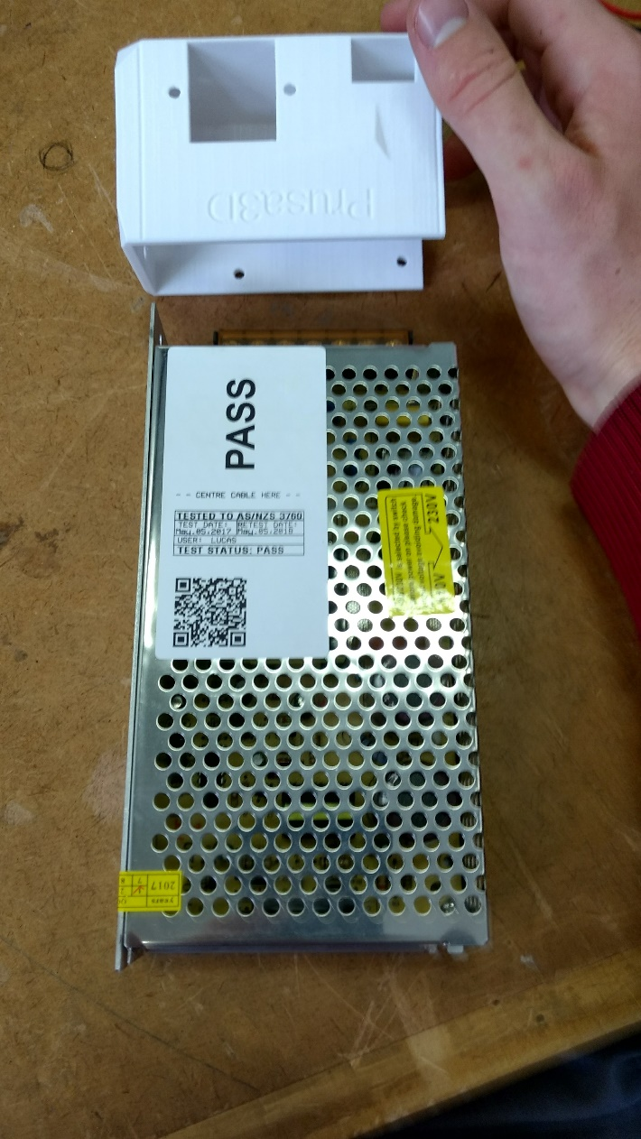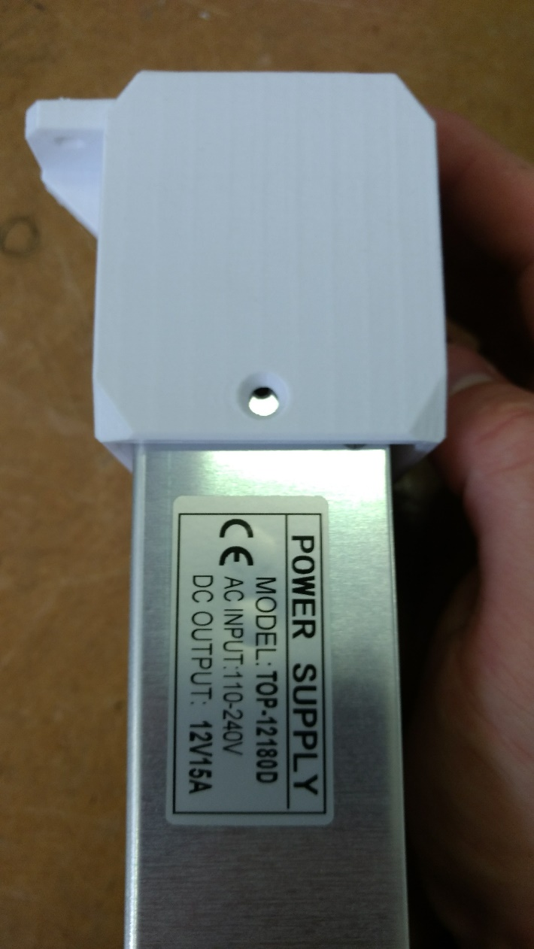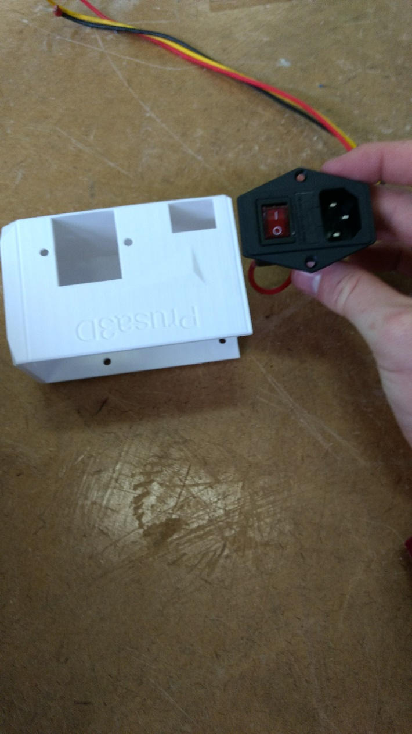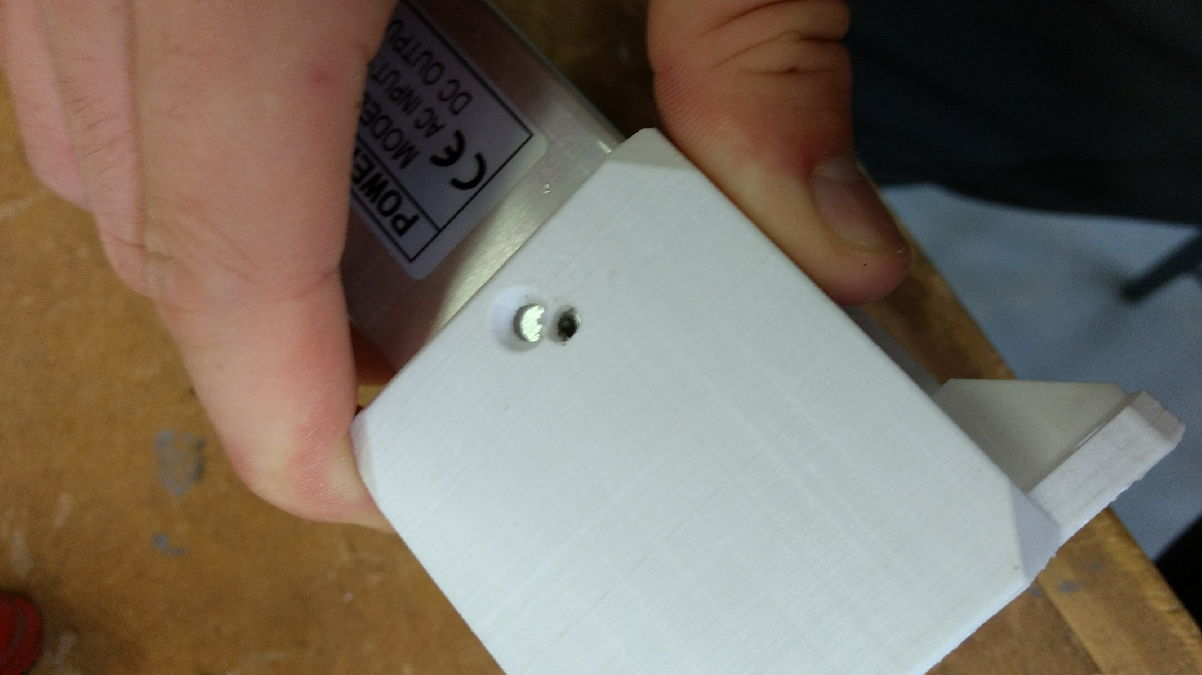

To redesign the power supply setup I first measured the dimensions of the power supply, and also the power switch.

22/05/17

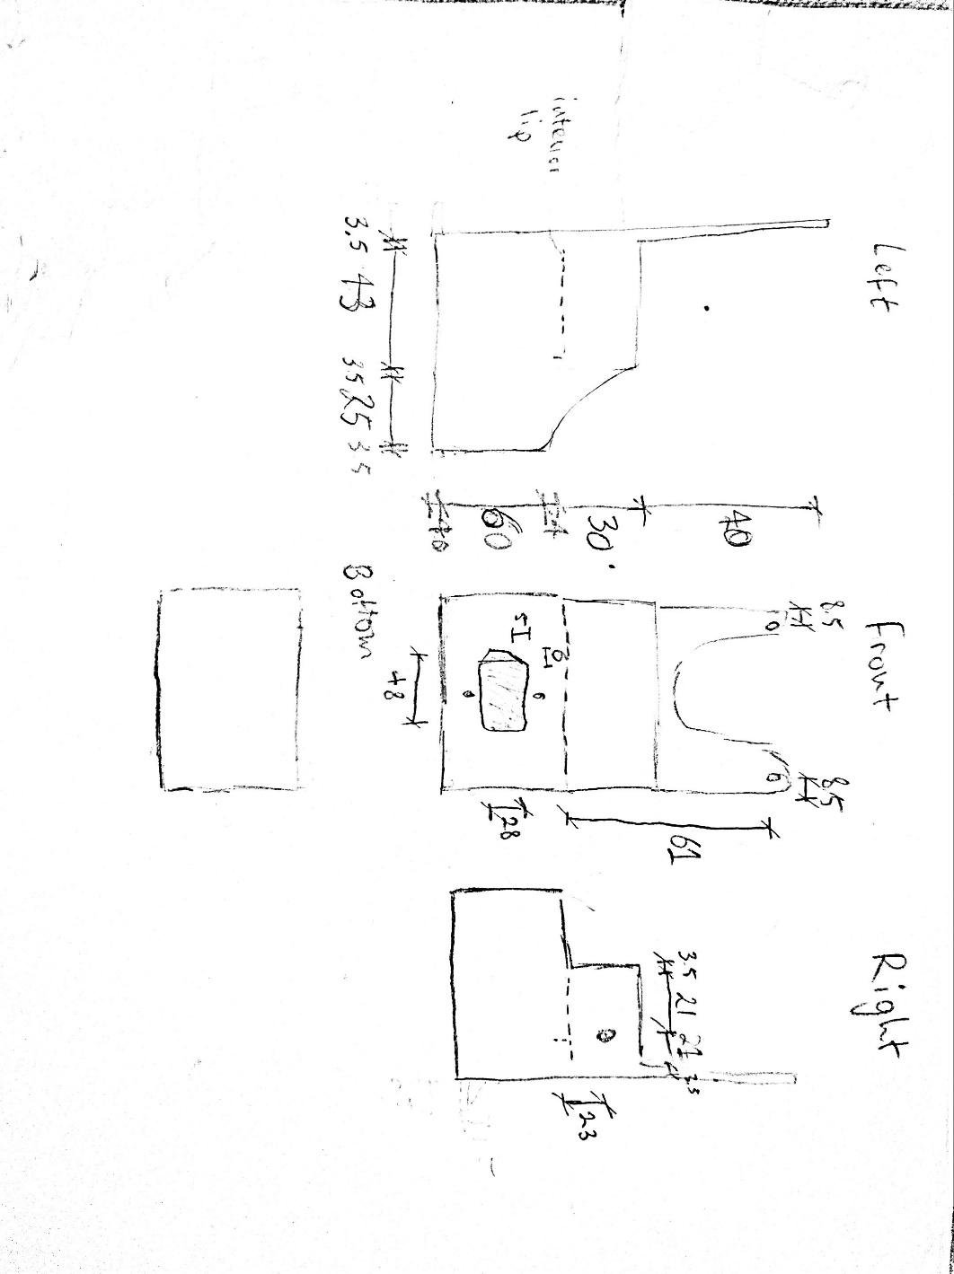 **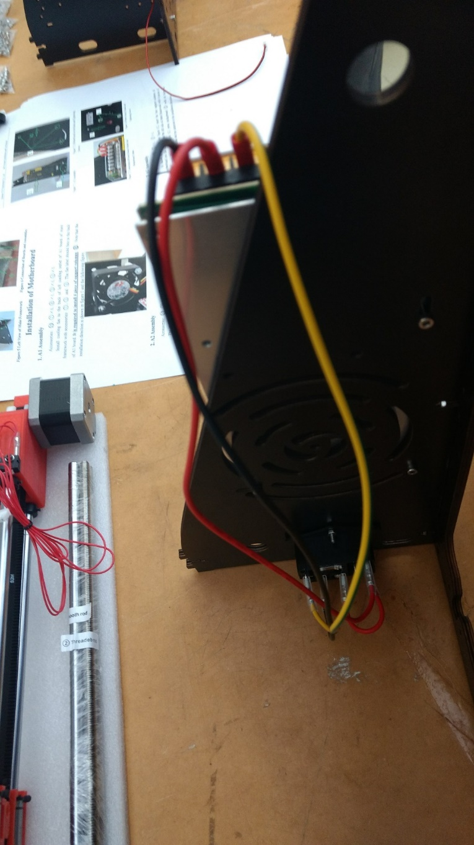**

Sketches and measurements above (left). Old PSU setup (right)

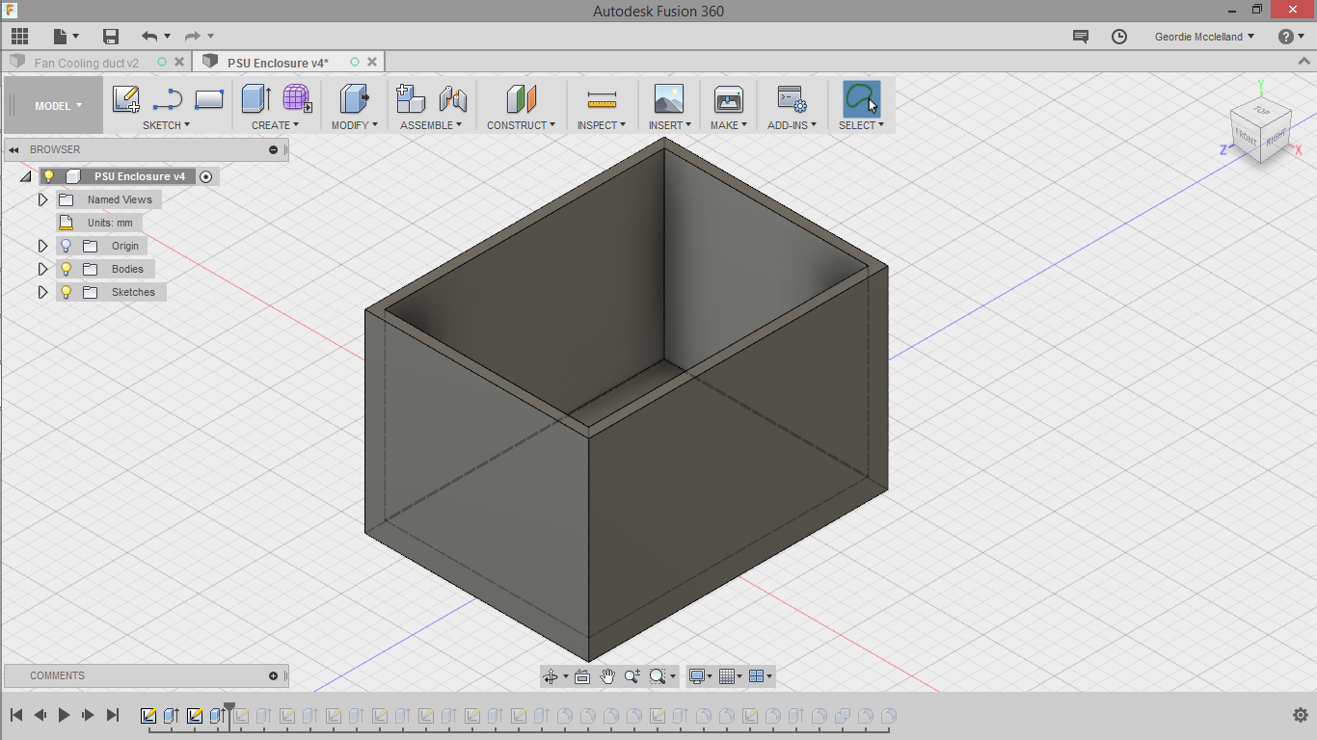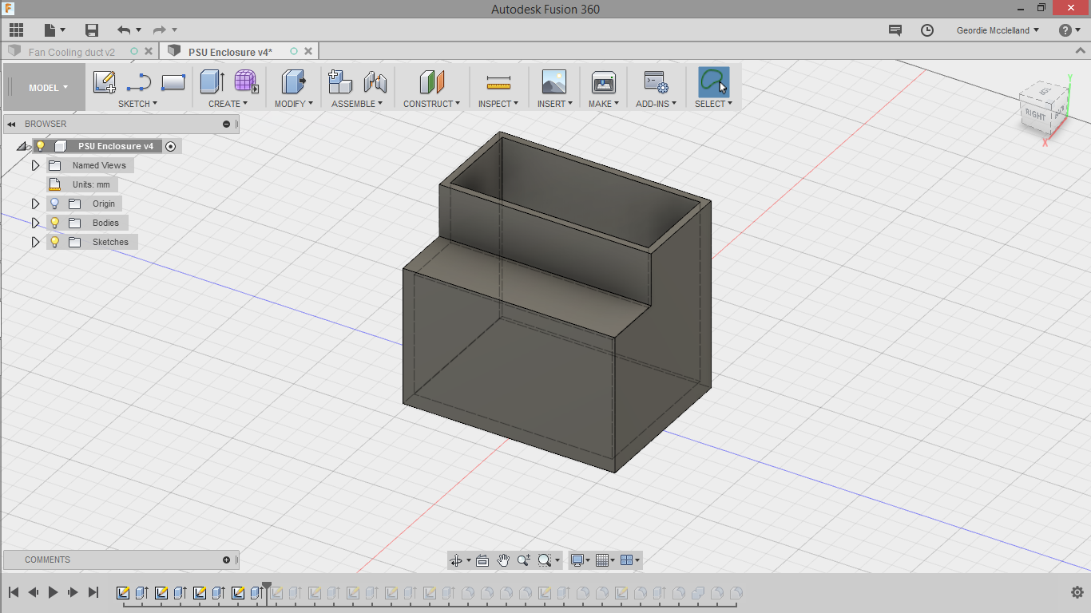

First I created the main housing, somewhat bigger than the dimensions of the power supply, I then created a slot that would be the dimensions of the power supply, allowing it to just slide in.

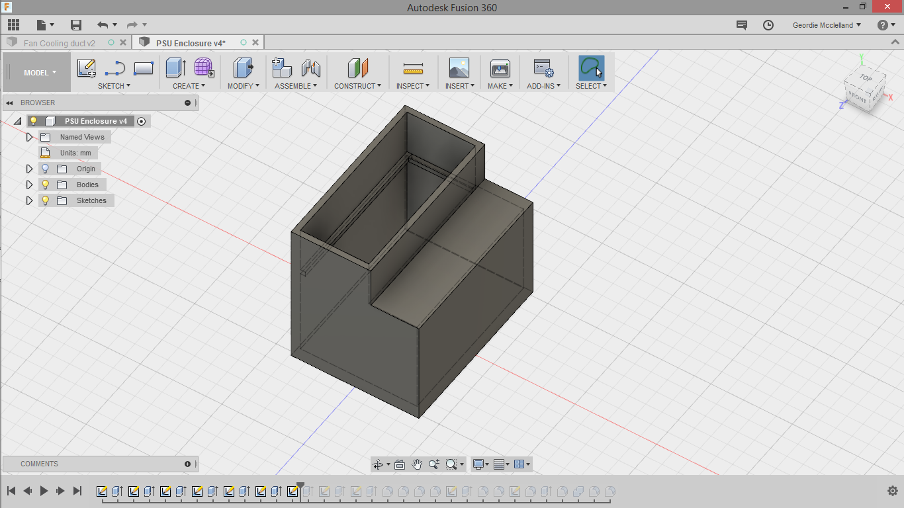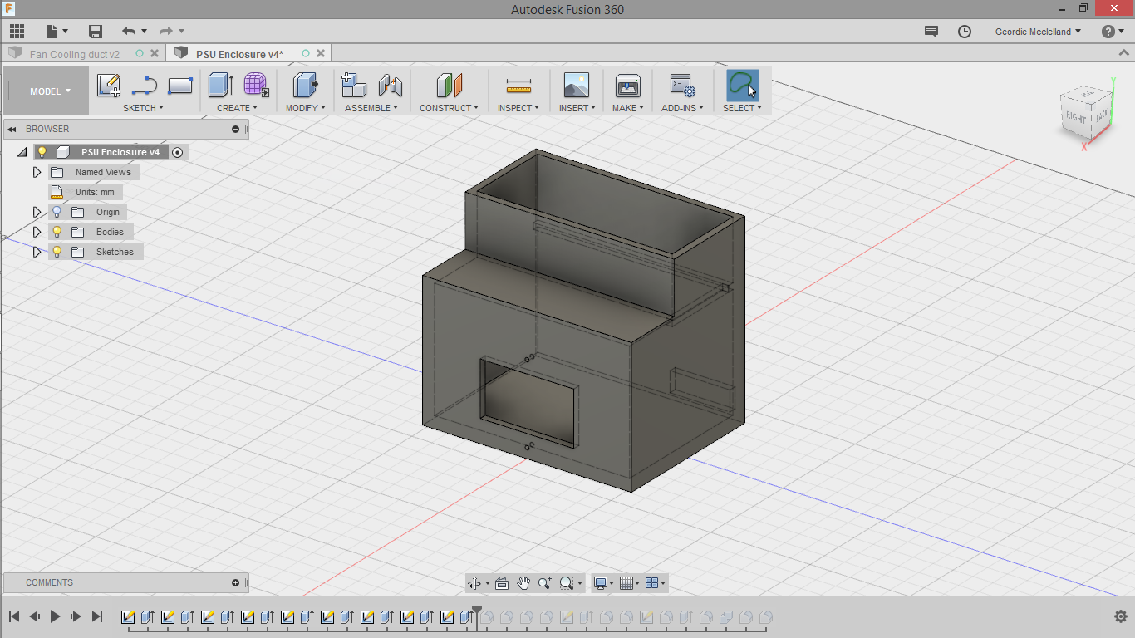

Next I added a small ridge to the slot, to act as a stopper for the power supply, only letting it slide in a certain amount. I then cut-out two holes, the first one being the switch hole and the second one being to run the 12V wires through.

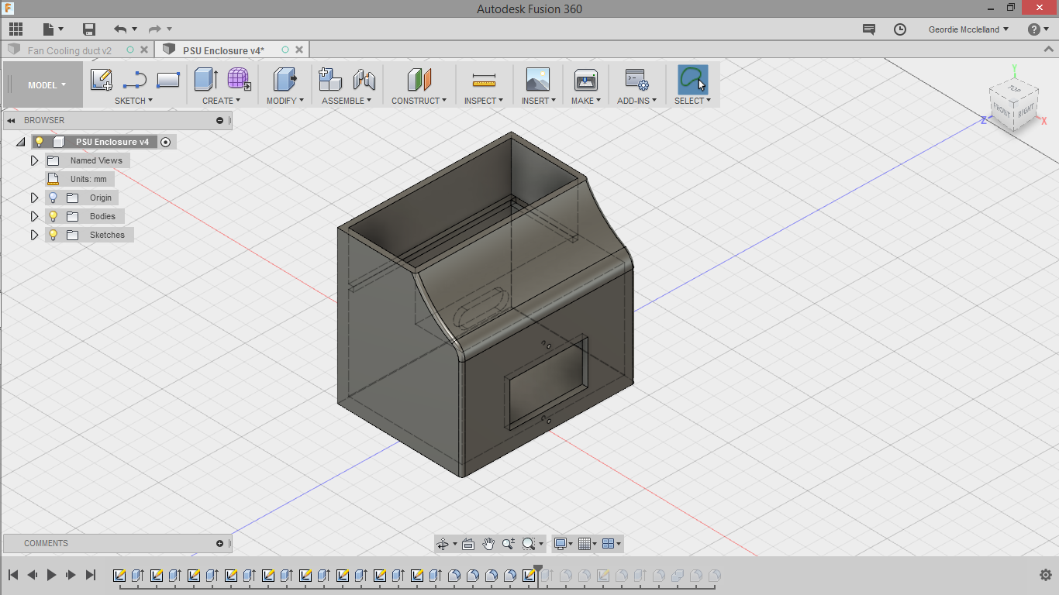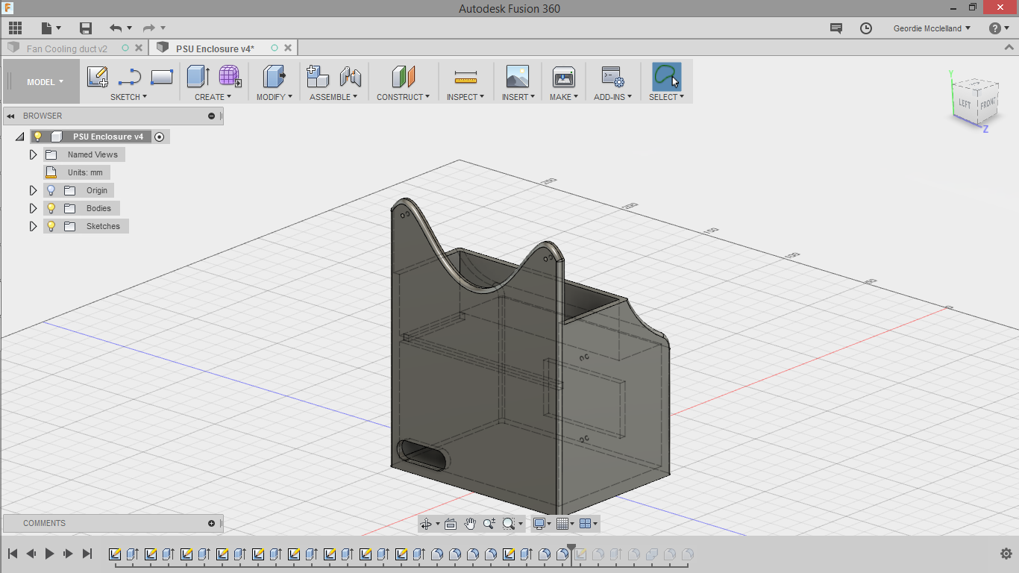

I then added some fillets to the edges, to give the case a more organic and natural look, while also making it safer (no sharp corners). The final step was using a spline to create an extrusion including screw holes, measured to the power supply to fix it in place.

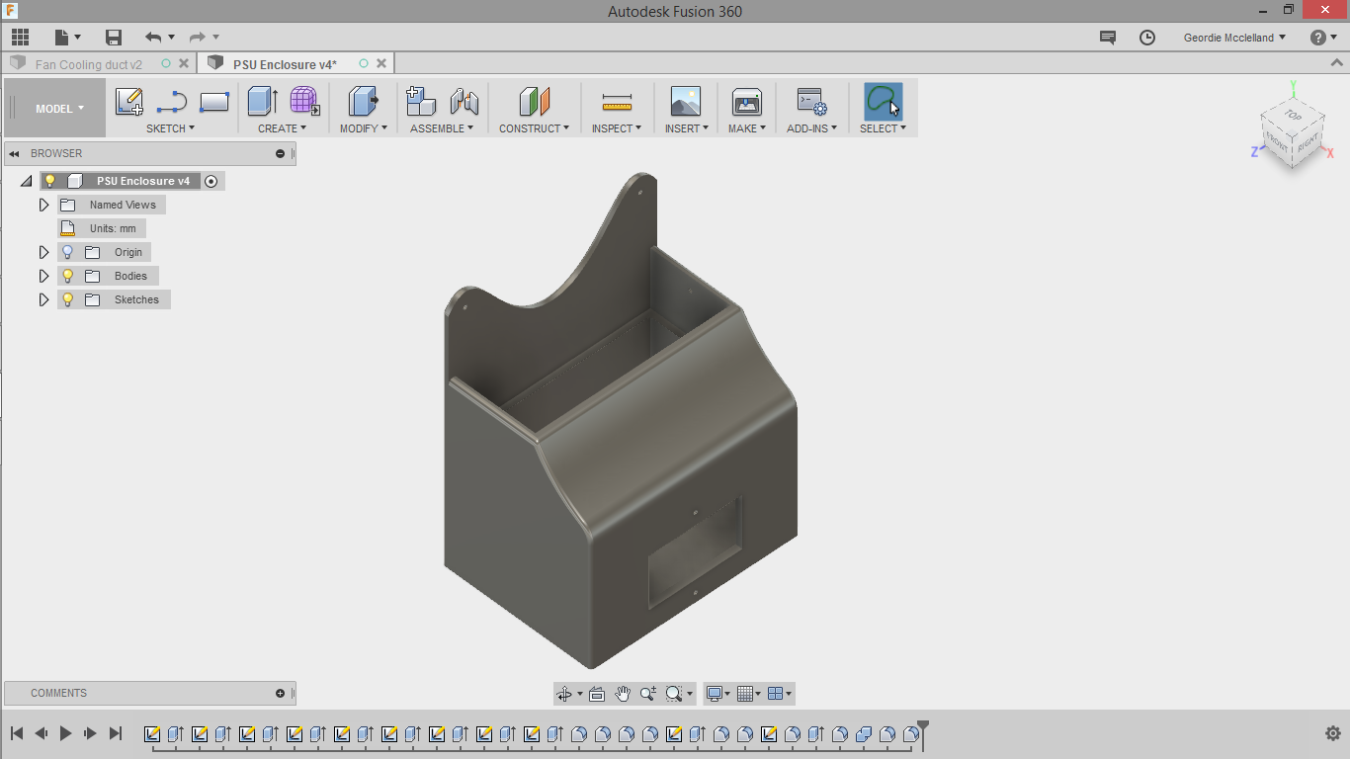  
This is the final design, and after this, all that was required was to export it as an STL file and then print it on a printer at school.

23/05/17

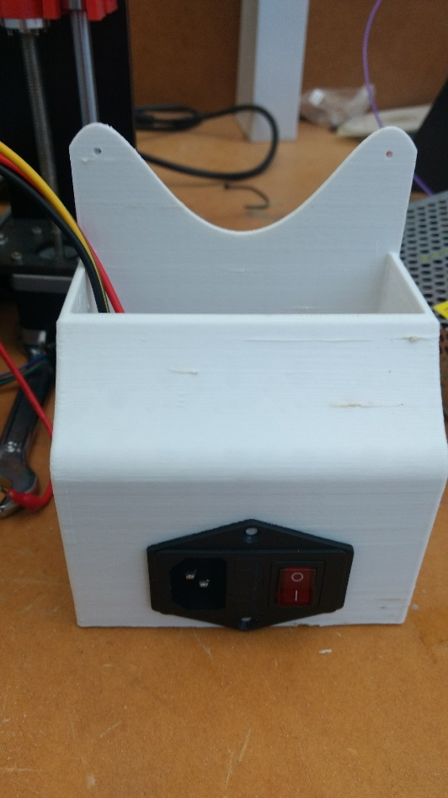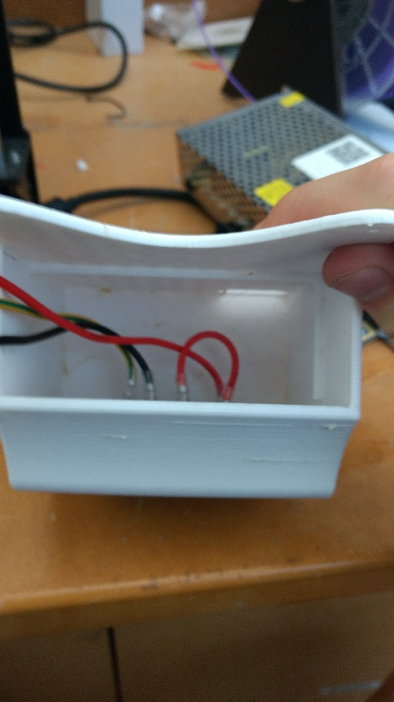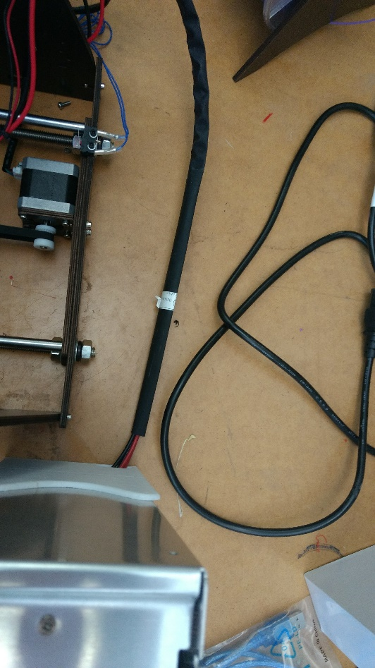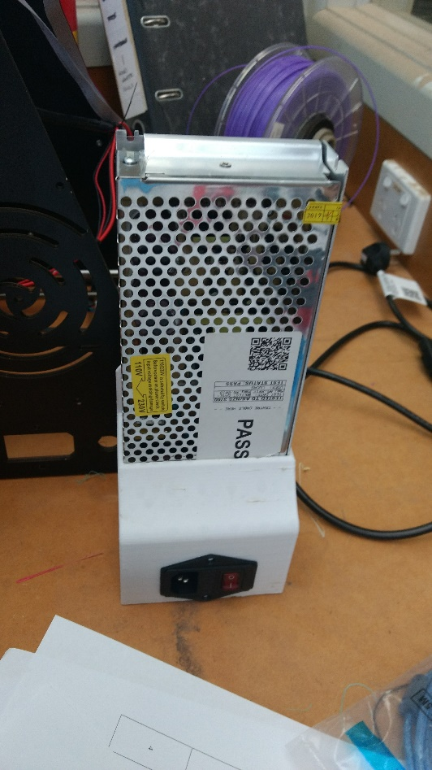

The switch fit perfectly snugly and I wired up the power supply completely again through the holes. The power supply being held in place by friction alone, but also some screws in the end.

|  |  |  |  |  |  |  |  |  |
| --- | --- | --- | --- | --- | --- | --- | --- | --- |
|  | | | | | | | In step 25, attaching the bed to the main frame of the printer, because the two small m3 screws on each side only held the frame together flimsily, I decided to attach two larger nuts on either side of the bigger threaded rod.  23/05/17 | |
| Between steps 28 and 32 the x-carriage is mounted, this is the left side, showing the threaded rod through the nut, as well as the smooth rod through the bearing, this went according to plan, although due to the tolerances of the machine, one side can be higher than the other, so it was important to line up both sides parallel to the heated build plate.  25/05/17 | | | | | | | | D:\Users\MCC0021\Downloads\SYSTEMS PHOTOS\IMG_20170420_124932001.jpg |
|  | This is the mounting of the screen (32), above the centre main part of the frame, locked securely in place with just two screws on the frame, this also did not vary from the original production plan.  25/05/17 | | | | | | | |
| In step 33 attaching this extruder assambly was fairly straightforward, however I did end up having to take it apart to access the screw holes, making it slightly more complex than it should have been. The other problem was that I didn’t have any screws long enough to reach through to the back of the x-gantry (where it was getting attached). In the end I just left the shorter screws in temporarily, until I got longer screws that I could properly thread through to the nuts.  29/05/17 | | | | |  | | | |
|  | | | | After mounting the motherboard as in step 27, I followed the wiring steps between 35-42, which went just as expected. Shown in diagram. | | | | |
| The main printer is now complete  29/05/17 | | | | |  | | | |
| Now finished wiring the 3d printer, it was done besides the enclosure. I decided to begin testing the print quality, skipping ahead to step 53. | | | | | | | | |
| While this first test seemed to work a little bit at the start, it slowly warped up away from the heated bed, which I eventually realised was due to the overly high temperature for the bed of 70 degrees celcius. After fixing this issue the extruder seemed to slowly stop pushing through plastic, which was a major setback, especially given the whole process of 3d printing relies on the output of molten plastic. After some research I found that this cheaper plastic is known to be not highly grippy, and in combination with the cheap components I think that is why it was unable to extrude properly.  29/05/17 | | | | | |  | | |
|  | | | I printed this tolerance test, testing to see with how much of a gap between plastic walls is necessary to be able to rotate the inside pieces, which are designed to be not connected to the body of the model at all. However due to the little cooling, but also the inaccuracies of the extruder extrusion, none of the wheels were able to be rotated. It is quite clear the roughness of the surface and it is definitely able to be improved.  05/06/17 | | | | | |
| Using a higher quality filament I printed this xyz calibration cube, designed at 20x20x20mm. As shown in the pictures the X axis was measured at 20.04, and the Y axis at 20.10. These dimensions are much closer to 20mm than I expected. However on the surface there is still quite significant deviation, and also even just in the overhangs of the letter insets, the plastic is sagging downwards.  The cube was printed with a raft (see appendix) but it ended up being completely fused and inseperable from the cube, I was still able to measure the dimensions, the total Z height being 22.14mm minus the 2.1mm raft leaving a height of 20.04, showing that all in all the stepper motors had the correct mm/step ratio set in the firmware.  06/06/17 | |  | | | | | | |

Fan Mount\Duct

After researching extensively about getting high quality surface finish on prints, I realised that a cooling fan for the material was very important, also especially for parts with overhangs, or that require bridging. Not only that but the cooling fan helps with the process for elements such as rafts or support, as the cooling fan makes sure that these elements are not fused to the main printed part, and that they can be separated easily. 08/06/17

|  |  |
| --- | --- |
| The first solution to this problem I decided was to use gooseneck flexible tubing, like used in lamps, allowing for an adjustable output and positioning of the air flow. While initially this seemed like a good idea, I quickly realised that it would be hard to mount, and also was not very good at holding its shape, possibly moving around mid-print, instead ruining a print rather than helping it.  In the end I decided it would be better to create a solid plastic mount for the fan.  08/06/17 |  |

**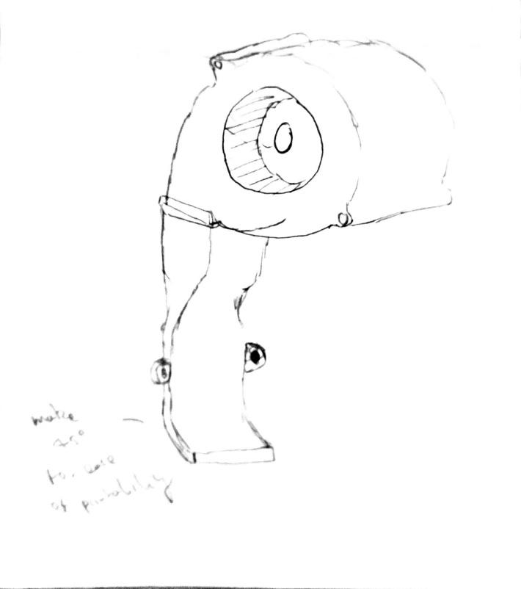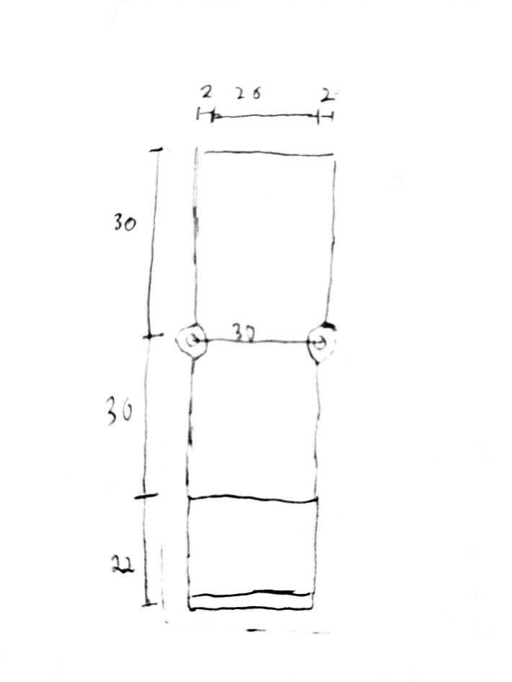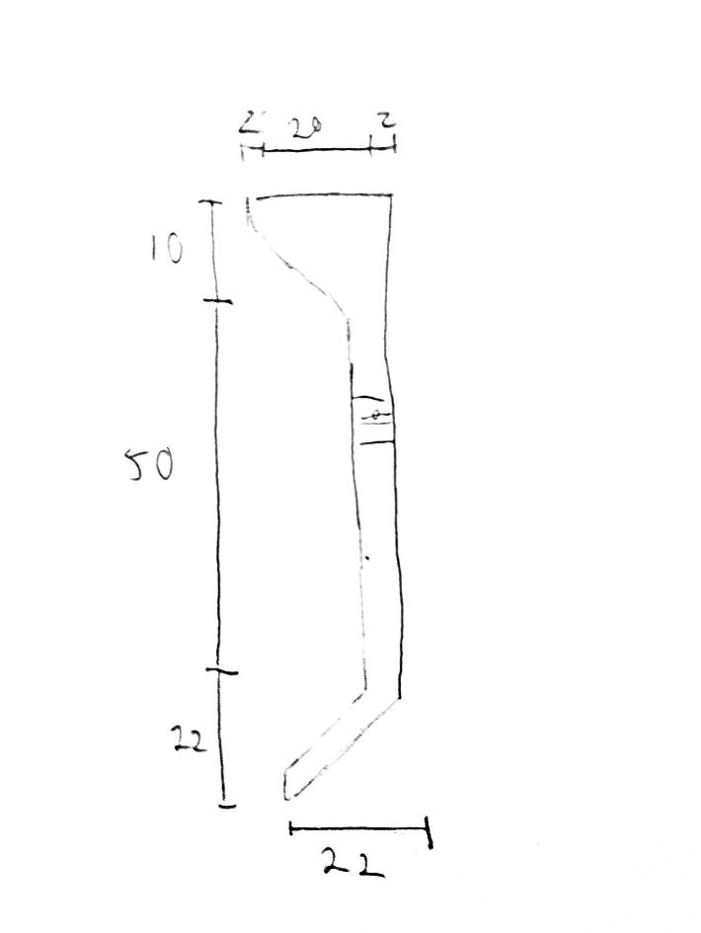**

Initial sketches and designs from measurements taken shown above, lining up with the extruder placement and holes. 08/06/17

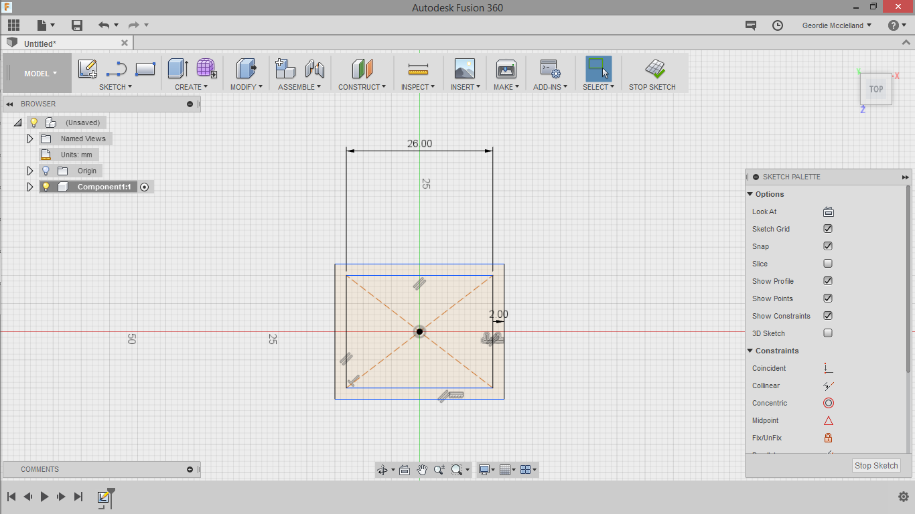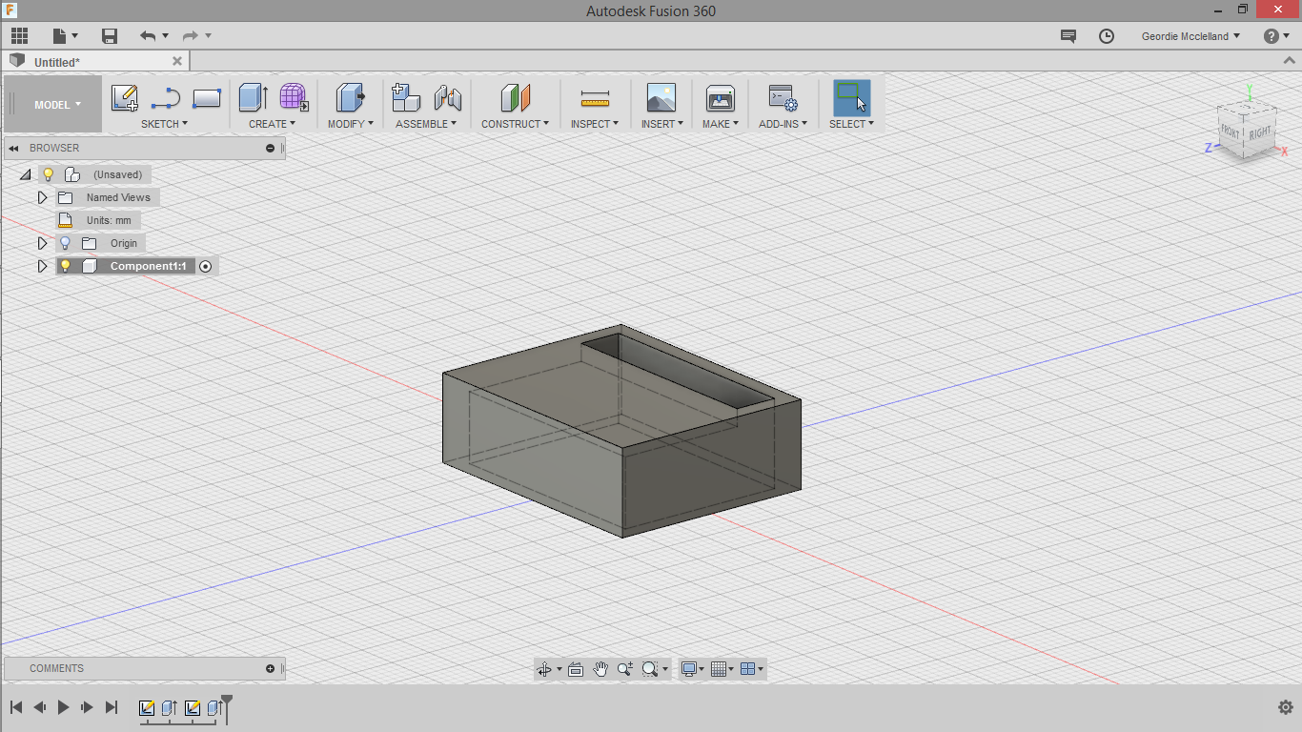

The first step was measuring the fan I would use, I then created a basic rectangle that could surround the fan, holding it in place. I made a small gap here for the airflow to really direct it in the one area. 12/06/17

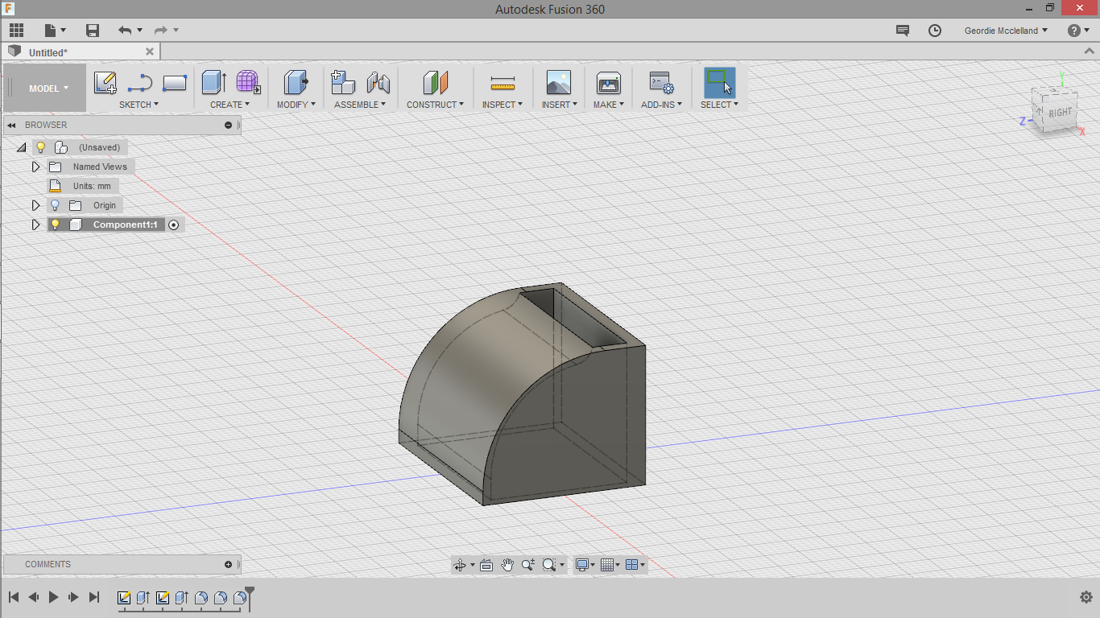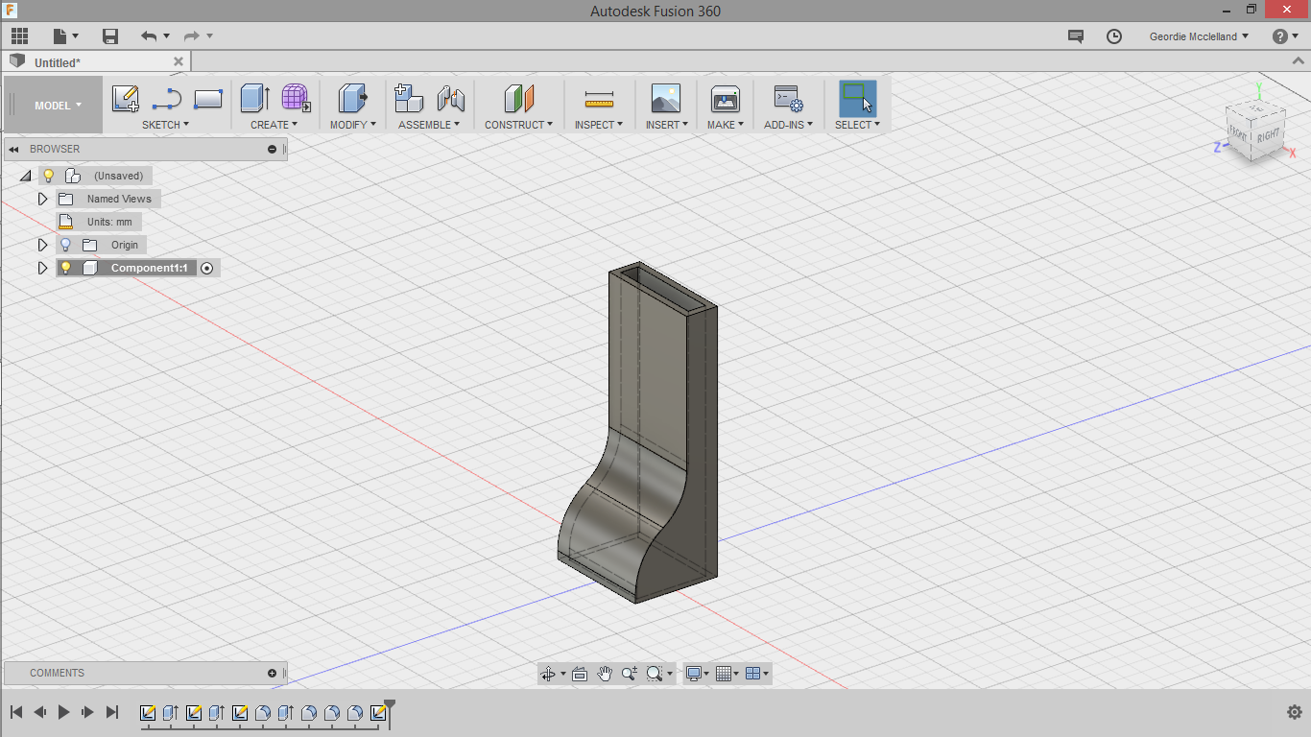

I then used the fillet tool to round the edges over to improve the airflow, then extending out a duct to run behind the extruder assembly. 12/06/17

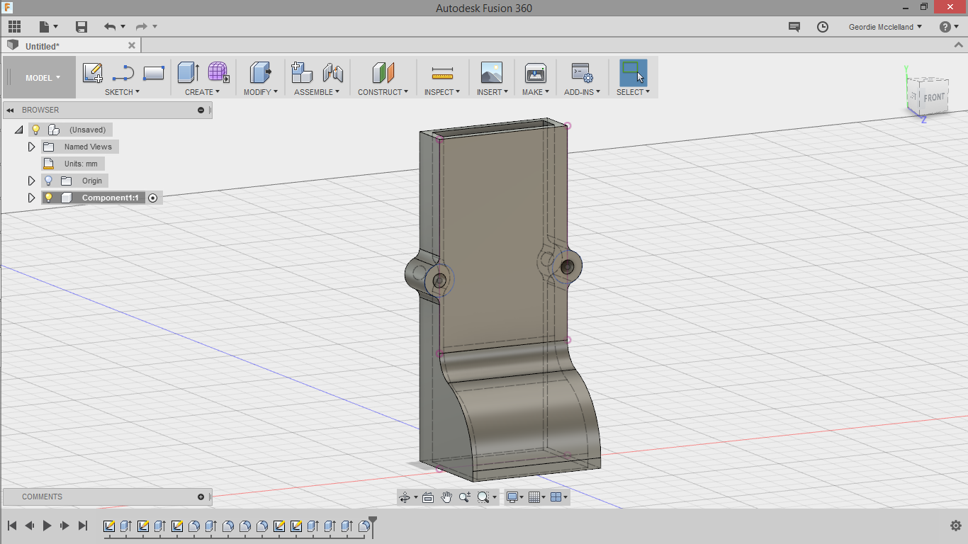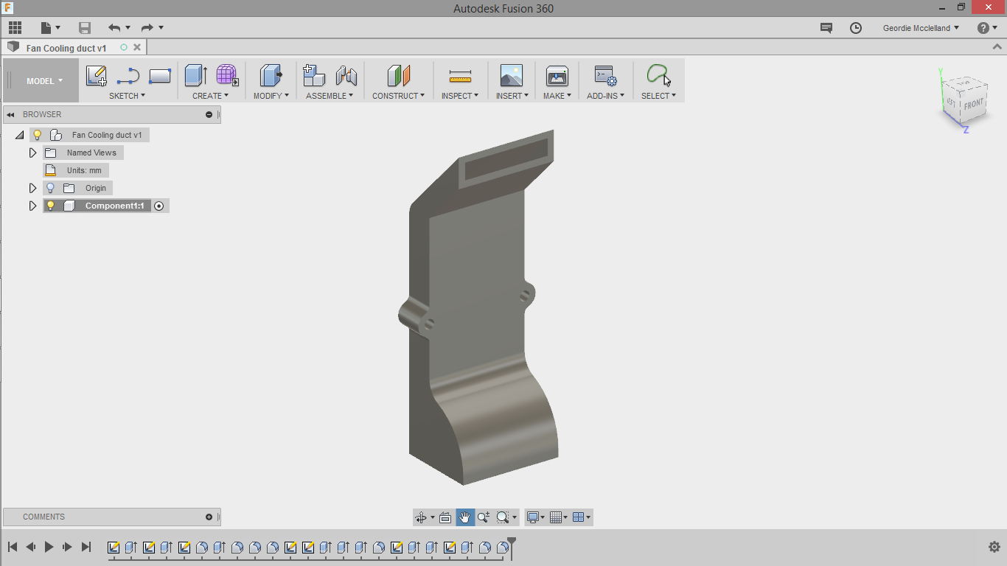

I added two screw holes measured to fit onto the assembly, then creating a final angled extrusion to aim the airflow towards the end of the nozzle. 12/06/17

|  |  |  |
| --- | --- | --- |
|  | | Printed and friction fit to the centrifugal fan.  13/06/17 |
| The fan is mounted here, and temporarily connected to a 9V battery  13-15/06/17 |  | |

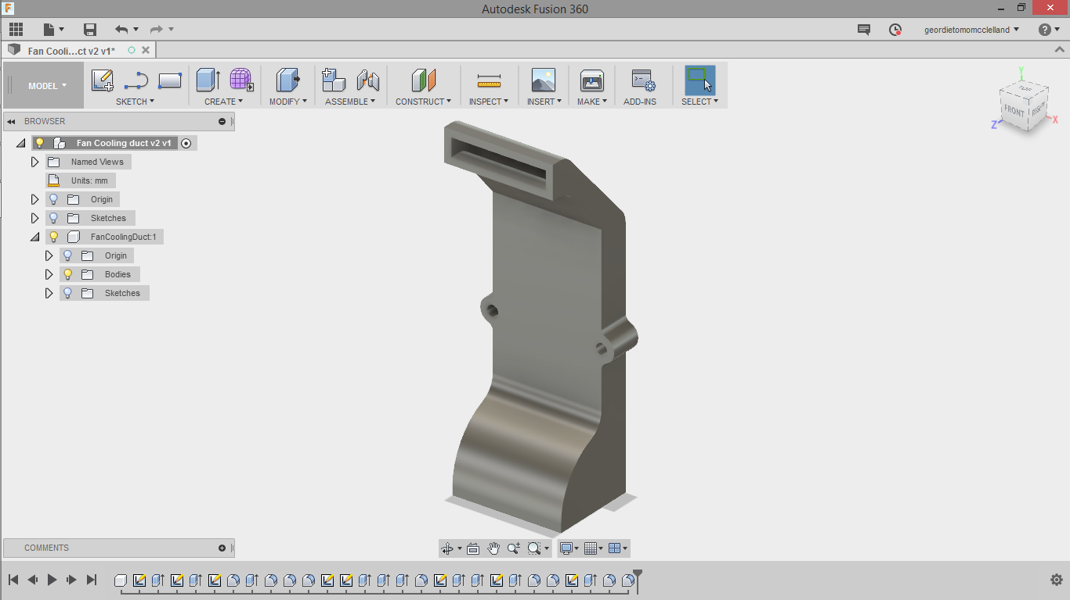

Upon printing the duct shown above, I realised it didn’t quite aim perfectly towards the tip of the nozzle, so I extended it a little bit, as well as straightening the angle to help its coverage.

15/06/17

|  |  |  |  |
| --- | --- | --- | --- |
| After some initial tests I found that the fan was not spinning fast enough with the 9V battery, so I wired it up to an adjustable power supply, running it at the required 12V of the fan.  19/06/17 | | |  |
|  | The first layer is laying down very well, quite obviously showing signs that it has been cooled well (matte finish, if it is molten it is quite shiny).  19/06/17 | | |
|  | | The tolerences on this model are even better than the first cube, and the raft was able to be seperated, due to the cooling fan. The letters are much more detailed, and the sides are much more uniform than the first one. However, this cube also shows significant underextrusion which also makes it feel weak and easy to break.  20/06/17 | |

Extruder (redesign)

Finding this problem with the extruder I decided to redesign it. The current extruder was one that just held the gear to the bearing with only friction, and in my research, most of the printers I had seen used some kind of spring to hold the bearing against the gear. 21-22/06/17

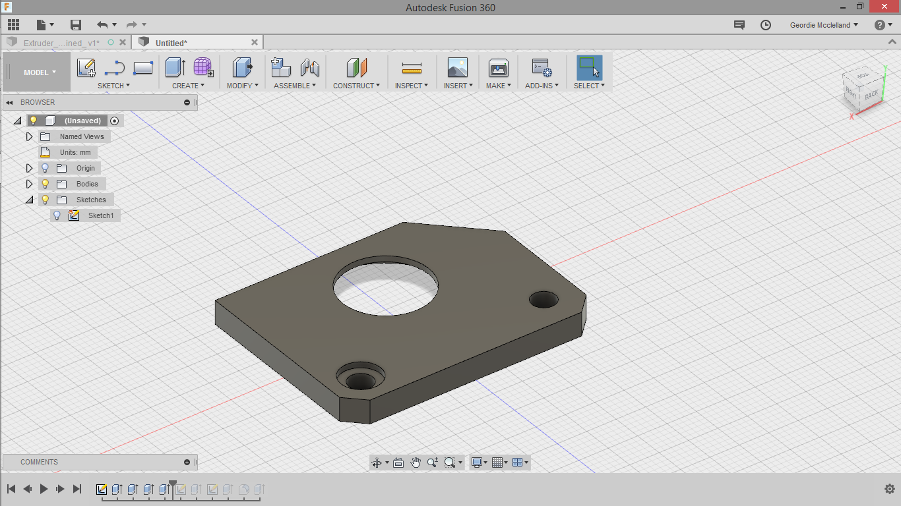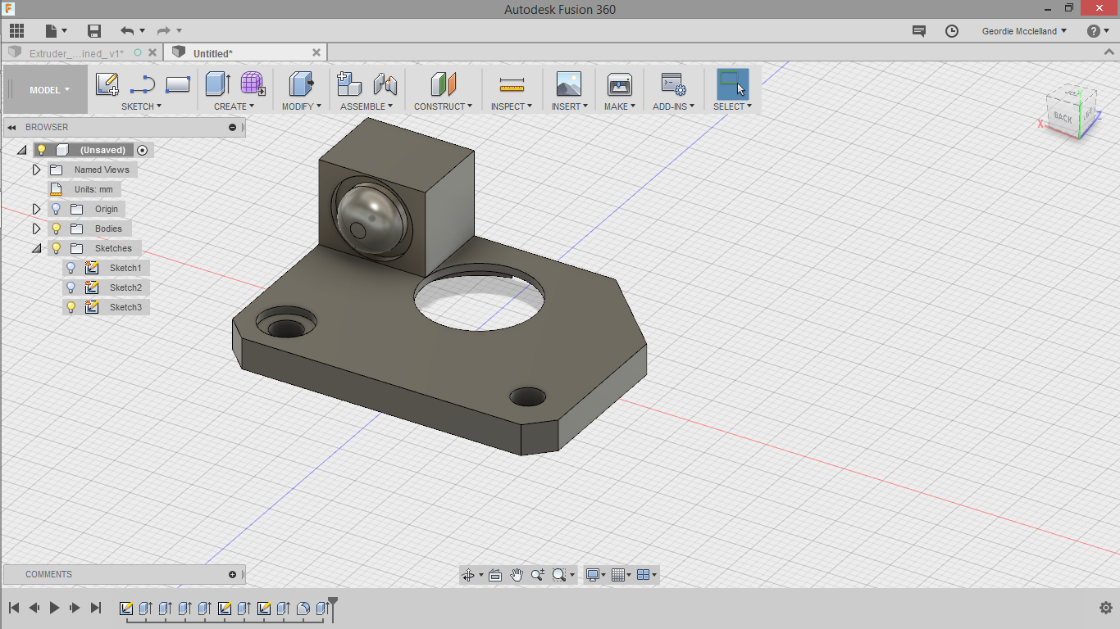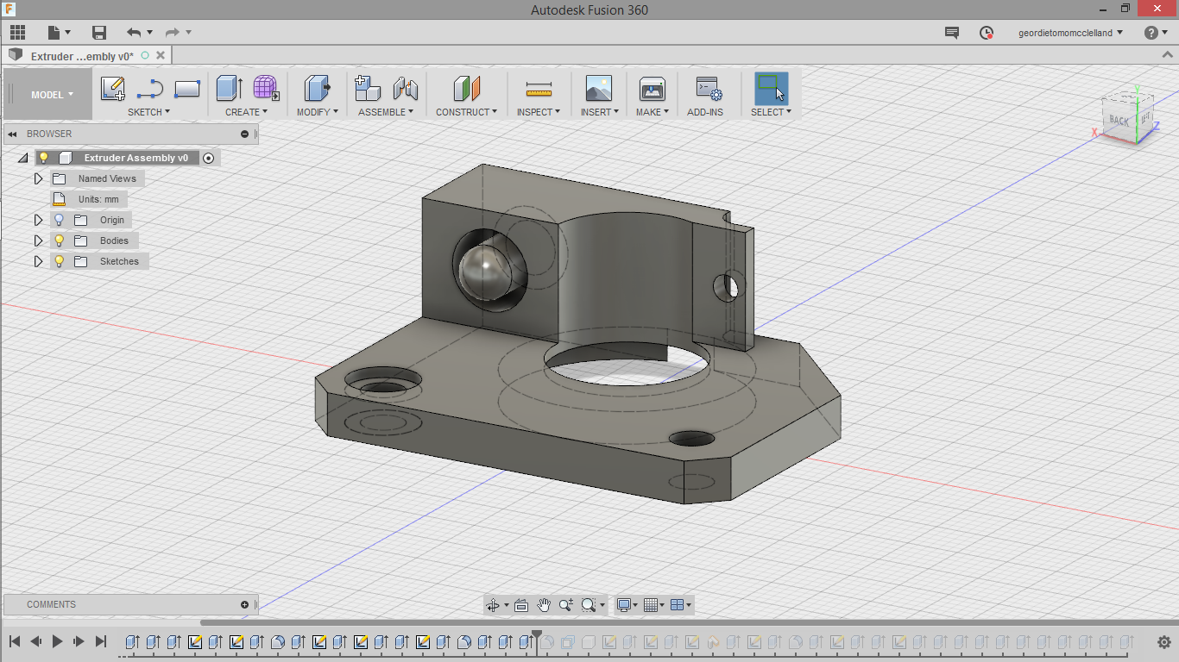

Creating the base of the extruder, designed to fit the nema17 stepper motor. This is loosely based off other extruders I had researched on google, however due to the hot end mount on this printer, it needs to be much shorter and compact, which is why I needed to create my own design.

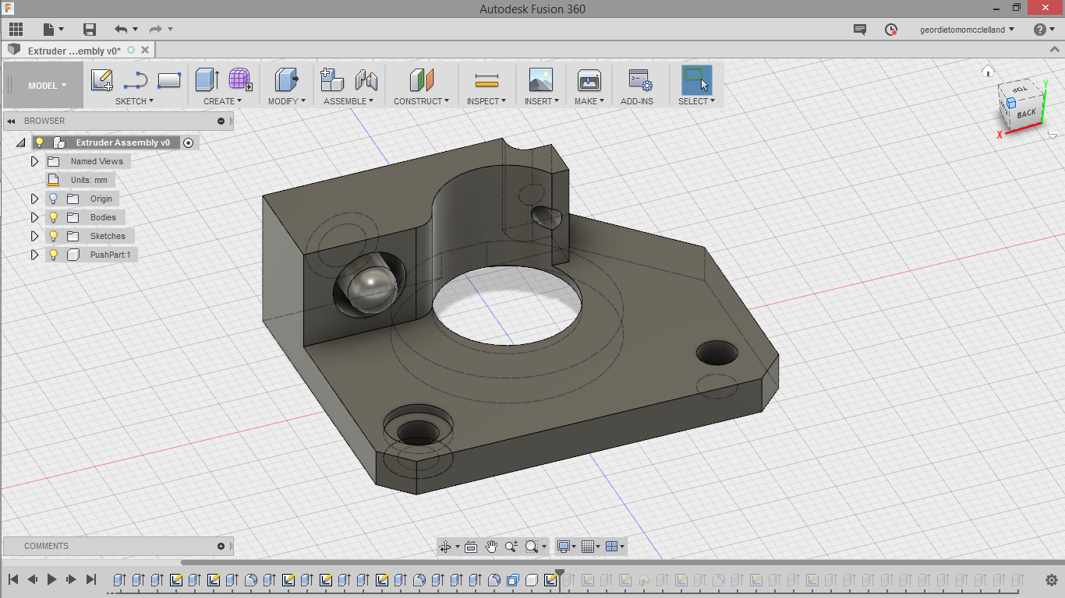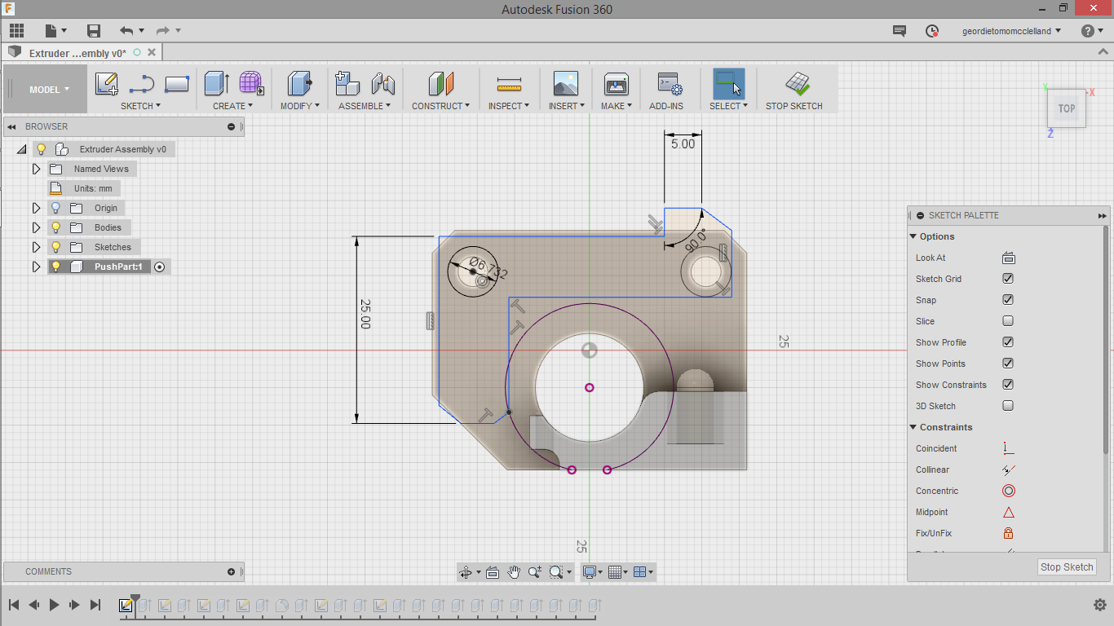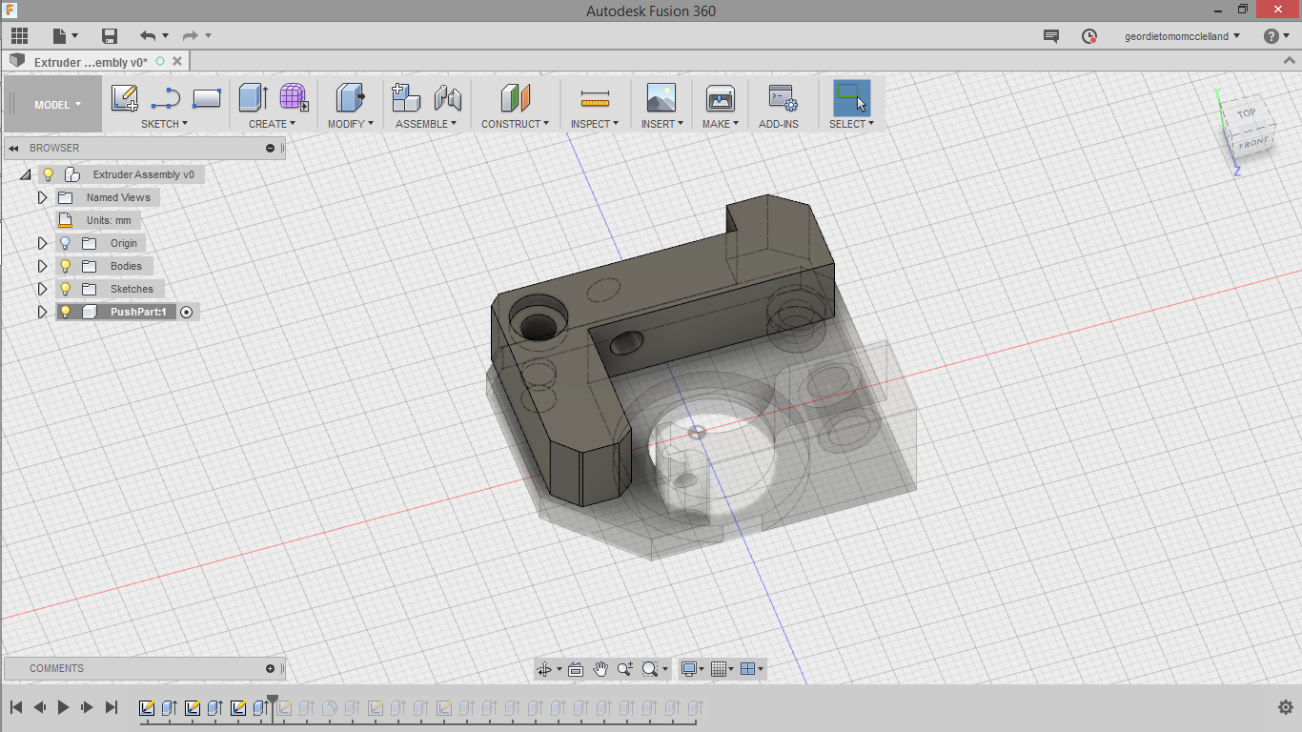

The first part is done here, the left cylinder is to mount the spring and the right hole is to feed the 1.75mm filament through. The arm is the part that holds the bearing and connects with the spring to apply pressure to hold the filament without letting it slip.

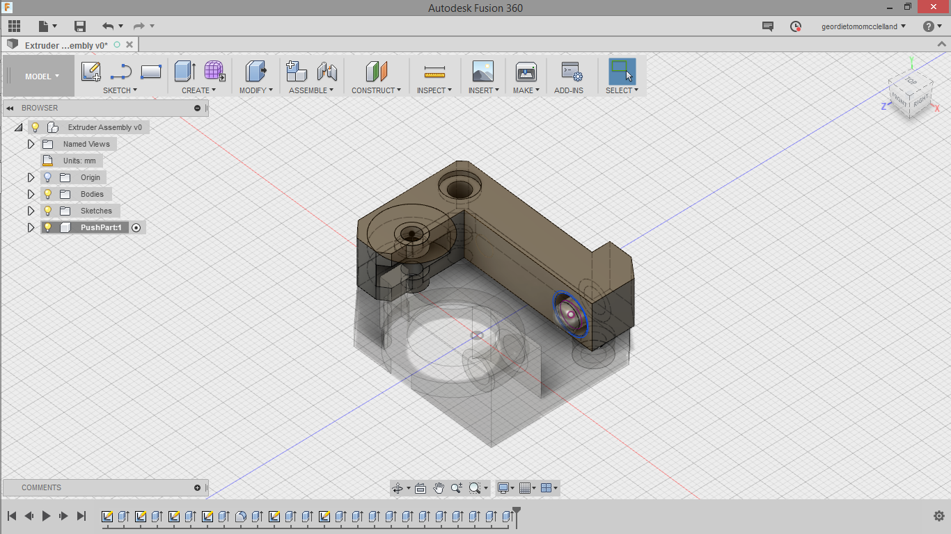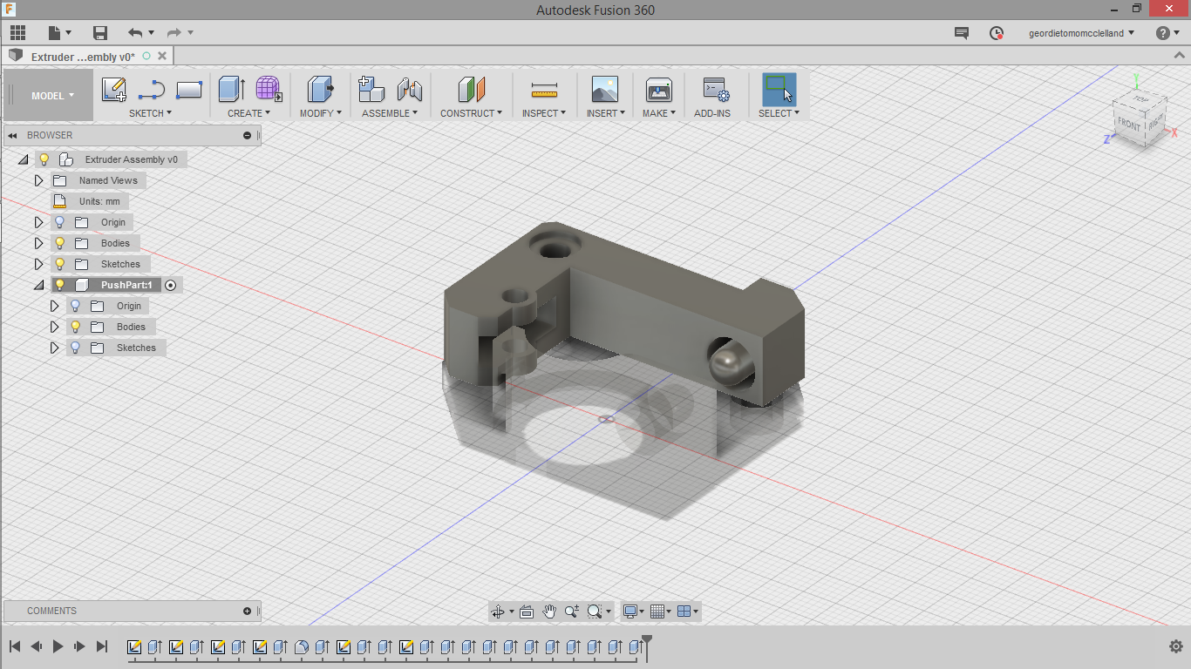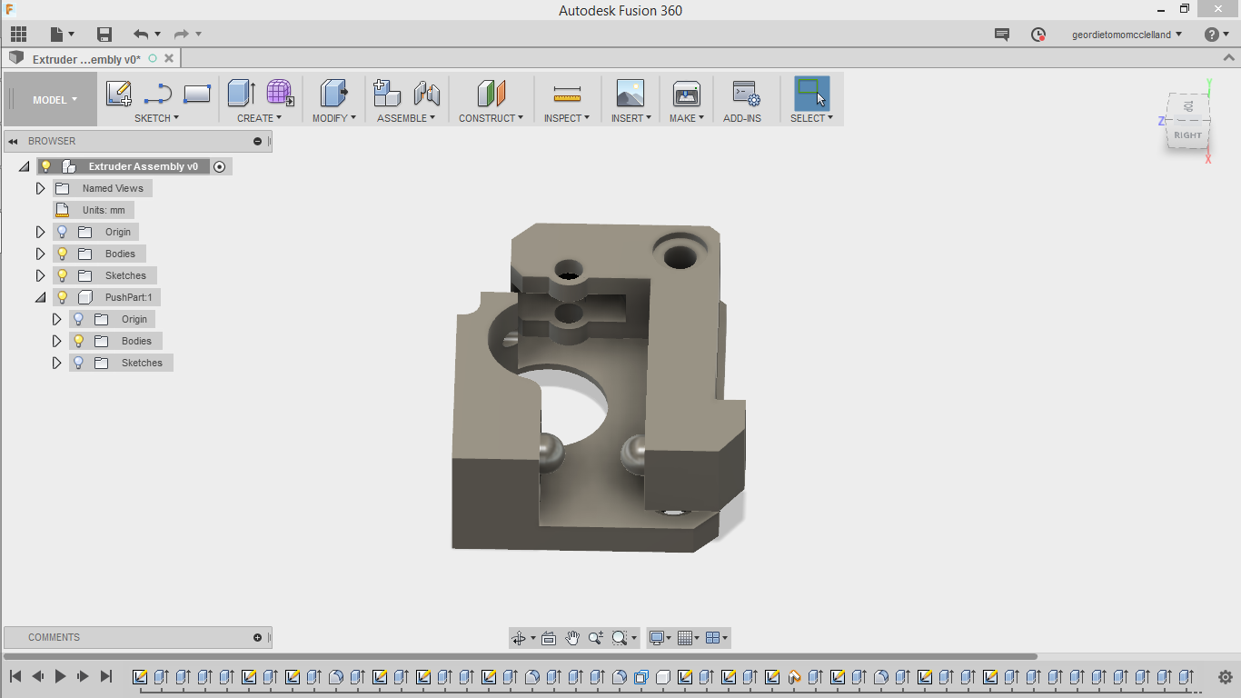

I will attach a washer between the two components to allow them to move more freely. The right picture shows the assembled extruder. 22/06/17

|  |  |  |  |  |  |  |  |  |  |  |  |  |  |  |  |  |
| --- | --- | --- | --- | --- | --- | --- | --- | --- | --- | --- | --- | --- | --- | --- | --- | --- |
|  | | | | | | | | I attempted to print the extruder on the printer in its current state, but due to the under-extrusion the part was weak, and snapped under the tension of the spring, after replacing the filament one time. You can see that it snapped along the layer lines, so next time I will print it in a better orientation to have strength along the axis that are tensioned.  The second photo is the bottom of the raft of the second print (using a better orientation for strength along the axis of tension) which quite clearly shows the skipped steps, as they are supposed to be smooth continuous lines not inconsistent.  23/06/17 (left) 26/06/17 (right) | | | | | | | | |
| This was the third extruder print using the second version printed above, and it came out very nicely.  It was quite smooth, and was easily separable from the raft, however the outside was still a little bit inconsistent. And already the tension on the previous version seemed like it would break at any moment.  Compared to the second version however it was much higher quality.  Once I had replaced the weaker versions, I began to have some other problems, which were actually because the spring was too tight, and with the proper part the filament was just getting stuck against the gear.  27/06/17 | | | |  | | | | | | | | | | | | |
|  | | | This was one of the prints with the replaced extruder, and the low quality finish and general weakness because of the over tight extruder is quite clear, basically the over pressure of the filament on the gear stops the motor from moving and causes these under-extrusion issues. I realised that my printed solution for the extruder was just not accurate enough to match the required tolerances of the finely tuned needs of a 3D printer.  28/06/17 | | | | | | | | | | | | | |
| I decided to use a bowden setup (having the extruder motor away from the heating element) instead of the original in hope that this more professional solution would help the printer run more smoothly, extruding plastic as expected.  17/07/17 | | |  | | | | | | | | | | | | | |
|  | | | | | | | | | I designed a mount for the bowden hotend in fusion 360, using two halves and gaps for m3 screws to clamp around the top of the hotend. The tolerances were too tight so the friction force alone was enough to hold the hotend in place. I also created a small rectangle hole that matched the size of my centrifugal fan, to just be push fit into the setup. The screw that holds the part to the x carriage however protrudes and blocks the mounting of the fan, so I had to cut the screw shorter using a hacksaw.  I wired the axial and centrifugal fan here in parallel to the plug of the original extruder fan, allowing them both to be powered by the 12V of the motherboard.  The last photo in this series on the right shows my attempted print with this setup, for the moment the actual motor having no mounting just sitting on top of the printer, and it didn’t work at all, while it was extruding a consistent line, it was nowhere near the amount of plastic it was supposed to be outputting. This was partly due to two reasons, the first being the connection of the tube to the hotend was not very good, and because it was just barely long enough, it would quite easily pull itself out mid print. The second reason was that the motor had no real place to be mounted, and I could not place it on top of the printer as it would intersect with where the enclosure would be seated over the printer. I decided to not further develop this setup and instead try something simpler.  21/07/17 | | | | | | | |
| I began working on step 49, bread-boarding my initial circuit for the Arduino 22-28/07/17, also testing some code, trying to get all the components working. | | | | | | | | | | | | | | | | |
| This is a part I designed for the metal extruder used above, but instead the idea was to attach it to the main head of the printer as the bowden tube was not working successfully, and also would have meant extending the case size. I discovered when attempting to mount this, that the fan and heatsink would need holes drilled in them because of the extra mounting hardware on the metal extruder that was extending out further than the original plastic one.  07/08/17 | |  | | | | | | | | | | | | | | |
|  | I decided due to all the previous problems I had been having with the extruder that my best option would be to completely replace the assembly. I ordered the fairly common, but more reliable mk8 extruder from Aurarum, replacing my original mk6 extruder clone that I had, which originally contained no form of tensioning on the gear. I also bought a new stepper driver, as I had seen online that often without enough current extruders could often have problems like shown above.  10/08/17 | | | | | | | | | | | | | | | |
|  | | | | | | I completely remodelled the fan mount (labelled appropriately v683, or what felt like it anyway) for this new extruder, fixing all the small problems with the previous version. 1. Mounting the fan parallel to the main frame rather than perpendicular where it would hit the top of the frame if extending to the full build volume in the z. 2. Extending the plate that it is held in to increase the stability of the attachment to the x carriage also reducing possible unwanted movement. 3. Making the air duct curved rather than angularly jutting out.  11/08/17 | | | | | | | | | | |
| Printing this redesign of my fan cooling duct on a high quality printer. This demonstrates a good raft (see the bottom) and also good supports and finish of the part.  15/08/17 | | | | | | | |  | | | | | | | |
| I was stuck waiting for the extruder to arrive now so I decided to move on to building the main enclosure, plus setting up the Arduino subsystem.  Assembled the Ikea Lack side table (43).  17/08/17 | | | | | | | | | | | | | |  | |
|  | | | Using the table saw, after removing each leg, I cut small grooves in each of the table legs, marking which sides needed cutting to accommodate three panels of acrylic (44).  (The fourth is a door that screws on with hinges)  17/08/17 | | | | | | | | | | | | |
| The acrylic was cut into a long 400mm wide strip, which I then cut the individual panels to their required size using the reciprocating saw (45). These then somewhat easily slotted into the sides of the table.  17/08/17 | | | | | | | |  | | | | | | | |
|  | | | | | | | | I cut the last piece using the table saw on all sides, as I thought this would give the cleanest cut on all sides. I measured placements for three hinges and then drilled the 6 holes to accommodate them affixing them with m3 screws and nuts (47). I ended up deciding to actually make this side the left side, as access to the wiring, plus having a clean face on the front seemed like a better idea for accessibility and ease of use.  18/08/17 | | | | | | | |
| Attaching the scrap wood, was painted black (17/08/17) on the top to fit in with the colour scheme. Screwed in with four long self-tapping screws.  18/07/17 | | | | | | | | | | | | |  | | |
|  | | | | | | | | | | | | | | I drilled a small hole through the printer, and then printed a small dust filter which holds a sponge against the plastic as it is fed through, hopefully removing all dust before the filament enters the extruder (48).  21/08/17 | |
| The extruder arrived, and I was moving on to setting that up. 22/08/17 | | | | | | | | | | | | | | | |
|  | | | | | | In the end I had to modify the cooling fan duct with a heat gun, allowing me to remould its shape, as when designing it I didn’t account for the sideways offset of the new extruder (which I hadn’t seen at this point) by about 10mm, so that the air would actually be blowing just under the nozzle rather than to the side. I could have reprinted the part, but that seemed wasteful given the solution fully worked at this point, and also due to time constraints being tight.  22/08/17 | | | | | | | | | |
| Installing the fan mount and extruder to the printer. I was able to reuse the metal bracket that attaches from the x-carriage to the original extruder, however I needed to drill holes in the plate to allow the new hotend and mounting hardware to fit. It is also resting in the enclosure here (although the paper is still on the acrylic – I thought it was best to leave that on for as long as possible given the school environment)  23/08/17 | | | | | | | | | | | | | | |  |
|  | | | | | | | | | | | | The stepper driver also arrived and I replaced the original red A4988 driver with the purple DRV8825 high current stepper driver.  23/08/17 | | | |
|  | | | | | | | | The initial lines of the raft are shown here in the left picture, and already their quality seems much better than previous tests.  Only a little bit further into this print, and it was showing significant signs of under-extrusion – different to previous iterations however: missing large segments of plastic. I could hear a click whenever it began extruding again, and I eventually figured out that the problem was due to the new stepper driver that was passing too much current and overheating, therefore shutting off before it could damage itself.  23/08/17 | | | | | | | |
| I found the specs of the driver:    So measuring its voltage, it was far too high at 1.648V, which would be outputting 3.3A, above the rated amperage for the board.  I wanted to set it approximately to 1A, so I aimed for around 0.5V (as 1A/2 = 0.5V). I ended up with 0.523V which was slightly higher than 1A, but much better than the initial setting.  24/08/17 | | | | | | |  | | | | | | | | |
|  | | | | | I printed with the new driver which was setup correctly and already this raft is much better than anything I had printed previously.  24/08/17 | | | | | | | | | | |
| This was the printed tolerance test, compared to the first purple one I printed, this one seemed much higher quality straight off the printer. Not only did it look better, it functioned better too, I was able to move the circles with the 0.5, 0.4 and 0.3mm gaps between the walls, comparing this to a more professional grade printer that the school owns, this is very good quality, as the school printer allowed only one extra to move, the 0.2mm gap.  24/08/17 | | | | | | | | | | |  | | | | |
|  | | | | | | | | | | | | | | The next steps involved drilling more holes through the roof of the enclosure. I had originally planned to keep the PSU inside the case, however, I thought that placing it on top would allow it to keep cooler while also being much more accessible to the user, whereby if a print is failing, they can quickly turn it off.  24/08/17 | |
| I wired up the Arduino according to my circuit diagram:    Converting from the initial breadboard to components soldered onto PCBs for a more permanent connection while also hot gluing the wires to the Arduino. This was of course after making sure my code worked with all of the components. However unlike initially planned I didn’t include the fans.  25-27/08/17 | | | | | | | | | |  | | | | | |

This is my final code for the Arduino, using the temperature and humidity sensors to display their values on the LCD and also changing the colour of the LEDs based on these values. I have attempted to explain what every line of code does to the best of my ability, comments marked by a double forward slash: “//”. The main problems I had setting up this program were actually to do with the sensor. Initially I thought that there would be inbuilt Arduino functions for dealing with the temperature sensor, however I eventually had to search the internet, to find a DHT.h library that would allow me to use my sensors function to the greatest of its ability.

25-27/08/17

1. #include <LiquidCrystal.h>  // importing a library for the display
2. #include "DHT.h"          // importing a library for the humidity and temperature sensor
4. DHT dht;                  // gives me access to all of the functions in DHT.cpp
6. // using these specific pins because they support PWM
7. **int** red = 11;               // red LED pin number
8. **int** green = 10;             // green LED pin number
9. **int** blue = 9;               // blue LED pin number
11. **int** brightness[] = {255,255,255}; // array that stores the current value of the LEDs in the following order R,G,B
12. // with a value between 0 and 255
13. **const** **int** FADE\_SPEED = 1;   // stores the value of the amount to increment the brightness of the LEDs
14. // and is constant because it should not change throughout the programs operation
15. **int** delayTime = 6;         // stores the value for the time in milliseconds between steps
16. **int** samplingPeriod;
17. **int** timePassed = 0;
19. **float** temp = 25;            // float to store the value of the temperature
20. **float** humidity = 60;        // float to store the value of the humidity
22. **const** **int** numRows = 2;      // number of rows and columns on the display
23. **const** **int** numCols = 16;
25. **int** asciiLetter;            // the current ASCII letter
26. **int** currentLetter = 0;      // current index letter of the word it is typing
28. **int**  thisRow = 0;           // current row on display
29. **int** thisCol = 0;            // current column on display
31. String topText = "Temp: ";         // main text to display on screen
32. String bottomText = "Humidity: ";
34. **int** stageOfWriting = 0;            // current stage of writing on the display, somewhat an abrotrary index using integers
36. // initialize the library with the numbers of the interface pins for the LCD display
37. LiquidCrystal lcd(8, 3, 4, 5, 6, 7); // 3 and 8 must be PWM pins otherwise these numbers are completely interchangable as long
38. // as you replace the physical connection
40. **void** setup() {  // runs once when the board turns on
42. Serial.begin(9600); // serial program setup for general testing through the computer
43. Serial.println();   // empty line
45. lcd.begin(numCols, numRows);  // begin the LCD function
46. dht.setup(2); // set the temp/humidity sensor data pin to 2
47. // sets the pins up as outputs (integers defined above)
48. pinMode(green, OUTPUT);
49. pinMode(red, OUTPUT);
50. pinMode(blue, OUTPUT);
52. // turns on all of the LEDs at max brightness
53. analogWrite(green, 255);
54. analogWrite(red, 255);
55. analogWrite(blue, 255);
57. samplingPeriod = dht.getMinimumSamplingPeriod(); // finds the sampling period of the sensor.
58. timePassed = samplingPeriod;                     // sets my timer variable to be the same as the sampling period
59. // this is because the first time it runs the humidity sensor
60. // will not have been used within the sampling period
61. }
63. **void** loop() {                                     // the loop method continually runs while the board is powered
64. **if** (timePassed >= samplingPeriod){              // if the timer is longer than the sampling period then it will be
65. // fine to recheck temperature/humidity
66. temp = dht.getTemperature();                  // gets the temperature and stores it in my temp variable
67. humidity = dht.getHumidity();                 // gets the humidity and stores it in my humidity variable
68. Serial.print("\t\t\n\nSTAT:");                // just some more print lines to the serial port (computer)
69. Serial.print(dht.getStatusString());          // for debugging
70. Serial.print("\t\nHUMID:");
71. Serial.print(humidity, 1);
72. Serial.print("\t\t\nTEMP:");
73. Serial.print(temp, 1);
74. timePassed = 0;                                // reset the timer to 0
75. topText = "Temp: " + (String) temp + "C";      // set the top text with the temp variable casted to a string
76. bottomText = "Humidity: " + (String) humidity + "%"; // set the bottom text with the humidity variable casted to a string
77. // check for state of writing
78. **while** (stageOfWriting < 2){
79. **if** (stageOfWriting == 0){        // stage 0 is writing out the top text
80. writeOutText(topText, 50, 1);  // passing in the values to my method coded below
81. // first parameter is text (String)
82. // second is the delay between each letter being typed in ms
83. // third is which line to go to next
84. }
85. **else** **if** (stageOfWriting == 1){  // stage 1 is writing out the bottom text
86. writeOutText(bottomText, 50, 0); // passing in the values to my method coded below
87. }
88. }
89. stageOfWriting = 0;                // reset the stage of writing
90. }                                    // and then exit the sample function until next time the sensor can be checked
92. fade(blue, 255);                // fade in the blue LEDs - signals printer is in operation
93. // but also acts as a constant light source
94. fade(blue, 100);                // fade down brightness and loop - creates a sense of breathing
96. **if** (temp > 40){                 // if the temperature of the enclosure reaches 40 degrees
97. fade(red, 255);                 // fade in the red LEDs
98. }
99. **else** **if** (brightness[red - 9] > 0) { // otherwise if they are on
100. fade(red, 0);                 // fade out the red LEDs
101. }
103. **if** (humidity > 60){           // if the relative humidity is greater than 60%
104. fade(green, 255);               // fade in the green LEDs
105. } **else** {                        // otherwise if they are on
106. fade(green, 0);                 // fade out the green LEDs
107. }
108. }

111. **void** writeOutText (String text, **int** delayBetween, **int** nextRow){
113. // set the cursor position
114. lcd.setCursor(thisCol, thisRow);
115. // cast the current letter to an int
116. asciiLetter = (**int**) text.charAt(currentLetter);
117. // write it out
118. lcd.write(asciiLetter);
119. // go to the next letter of the word
120. currentLetter += 1;
121. // go to the next column
122. thisCol++;
124. // if the next letter is not a valid letter
125. **if** (!text.charAt(currentLetter) > 0) {
126. // move to the next stage of writing
127. stageOfWriting++;
128. // reset the current letter variable
129. currentLetter = 0;
130. // go onto the next row
131. thisRow = nextRow;
132. // reset to the first column
133. thisCol =  0;
134. }
135. delay(delayBetween);
136. timePassed += delayBetween; // updates the time passed value
137. }
139. **void** fade(**int** pin, **int** fadeTo){   // method "fade" takes in a pin number and increases/decreases the output through PWM to the desired value "fadeTo"
141. // if the "fadeTo" value is greater than the current brightness increment
142. **if** (fadeTo > brightness[pin - 9]) {             // for loop begins with the input pin brightness and incrementing it by the fade speed
143. // all of my LEDs index in the array that stores thier brightness' are 9 less than their pin number
144. **for** (**int** i = brightness[pin - 9]; i < fadeTo; i += FADE\_SPEED){
145. brightness[pin - 9] = i;                    // set the brightness variable to "i" which is incremented above
146. analogWrite(pin, brightness[pin - 9]);      // actually write out the brightness to the board
147. delay(delayTime);                           // small delay to create the fading effect
148. timePassed += delayTime;                    // updates the time passed value
149. } **if** (brightness[pin - 9] > fadeTo){          // if the code somehow skips 255
150. brightness[pin - 9] = fadeTo;               // set it to 255
151. analogWrite(pin, brightness[pin - 9]);      // write out to the board
152. }
153. }
154. // otherwise is the "fadeTo" value is less than the current brightness decrement
155. **else** **if** (fadeTo < brightness[pin - 9]) {        // for loop starting with the current pin brightness and decrementing it by the fade speed
156. **for** (**int** i = brightness[pin - 9]; i > fadeTo; i -= FADE\_SPEED){
157. brightness[pin - 9] = i;                    // set the brightness variable to "i" which is incremented above
158. analogWrite(pin, brightness[pin - 9]);      // actually write out the brightness to the board
159. delay(delayTime);                           // small delay to create the fading effect
160. timePassed += delayTime;                    // updates the time passed value
161. } **if** (brightness[pin - 9] < fadeTo){          // if the code skips 0
162. brightness[pin - 9] = fadeTo;               // set to 0
163. analogWrite(pin, brightness[pin - 9]);      // write out to the board
164. }
165. }
166. }

|  |  |  |
| --- | --- | --- |
|  | Mounted the LCD screen in my bracket that I designed in fusion 360, accommodating for the small Arduino LCD but also for the larger printer LCD, also angling them towards the users eyes, for more comfort when using, as I had found the mounting parallel to the frame was uncomfortable using it for long periods of time.  I cut a big hole right behind the LCD mount and this is where the wires from the Arduino to the temperature/humidity sensor, RGB LEDs and wires from the printer LCD go through. I firmly mounted the LED strip around the underside of the roof of the enclosure, lighting up the whole enclosure, especially for dark environments, but also changing colour depending on conditions indicating to the user when it is hot, or over humid.  I also realised that the door would need something to hold it shut, so I found a small latch that would also act as a handle.  28/08/17 | |
| These were the computer fans I initially planned to install inside the case, however in the end I decided that they would leak more heat than it was worth, even when they weren’t on, so the enclosure is better just with the sensors that alert the user, who can then make changes if necessary such as opening the door. I even printed small brackets that I designed in Fusion 360 to connect them together, however, due to the time constraints also I decided the setup would be better without the fans.  28/08/17 | |  |

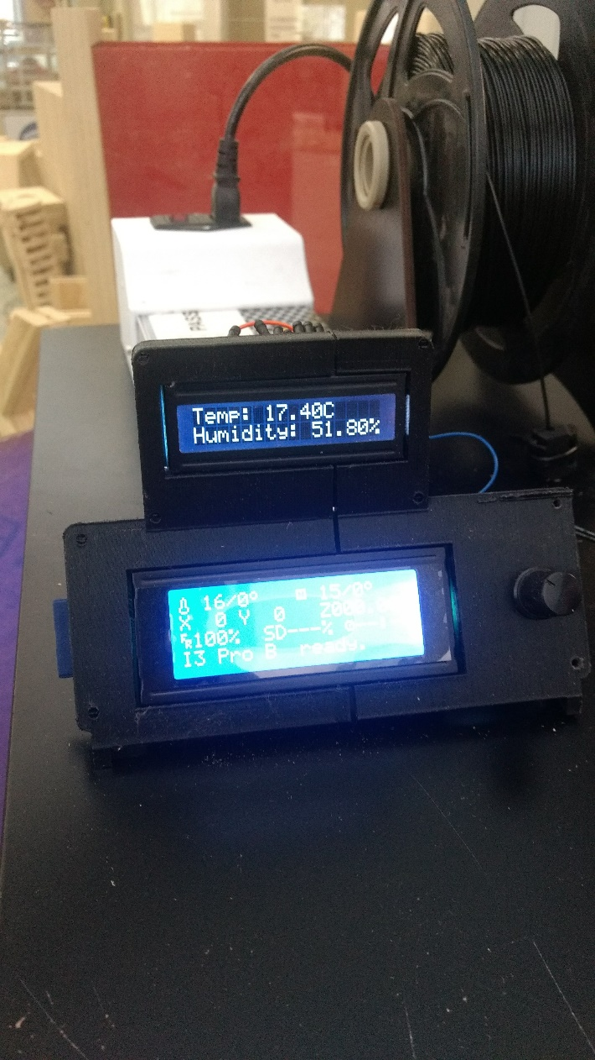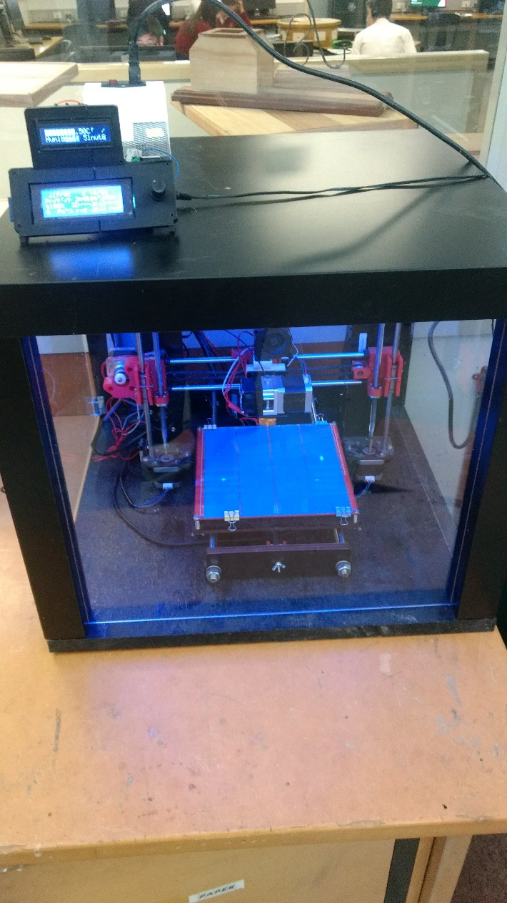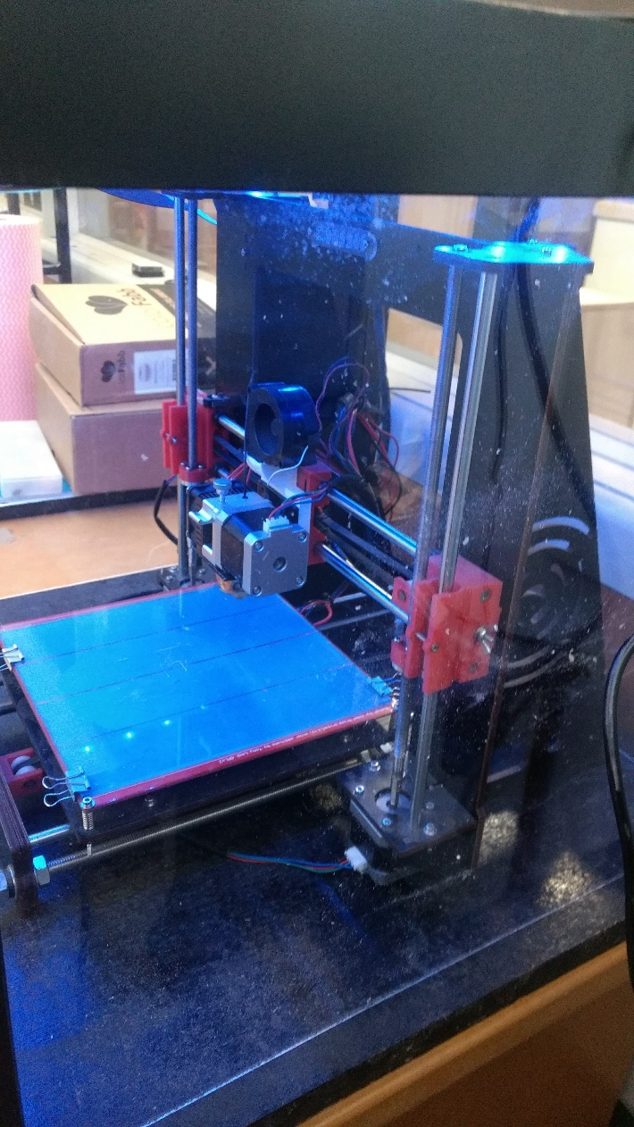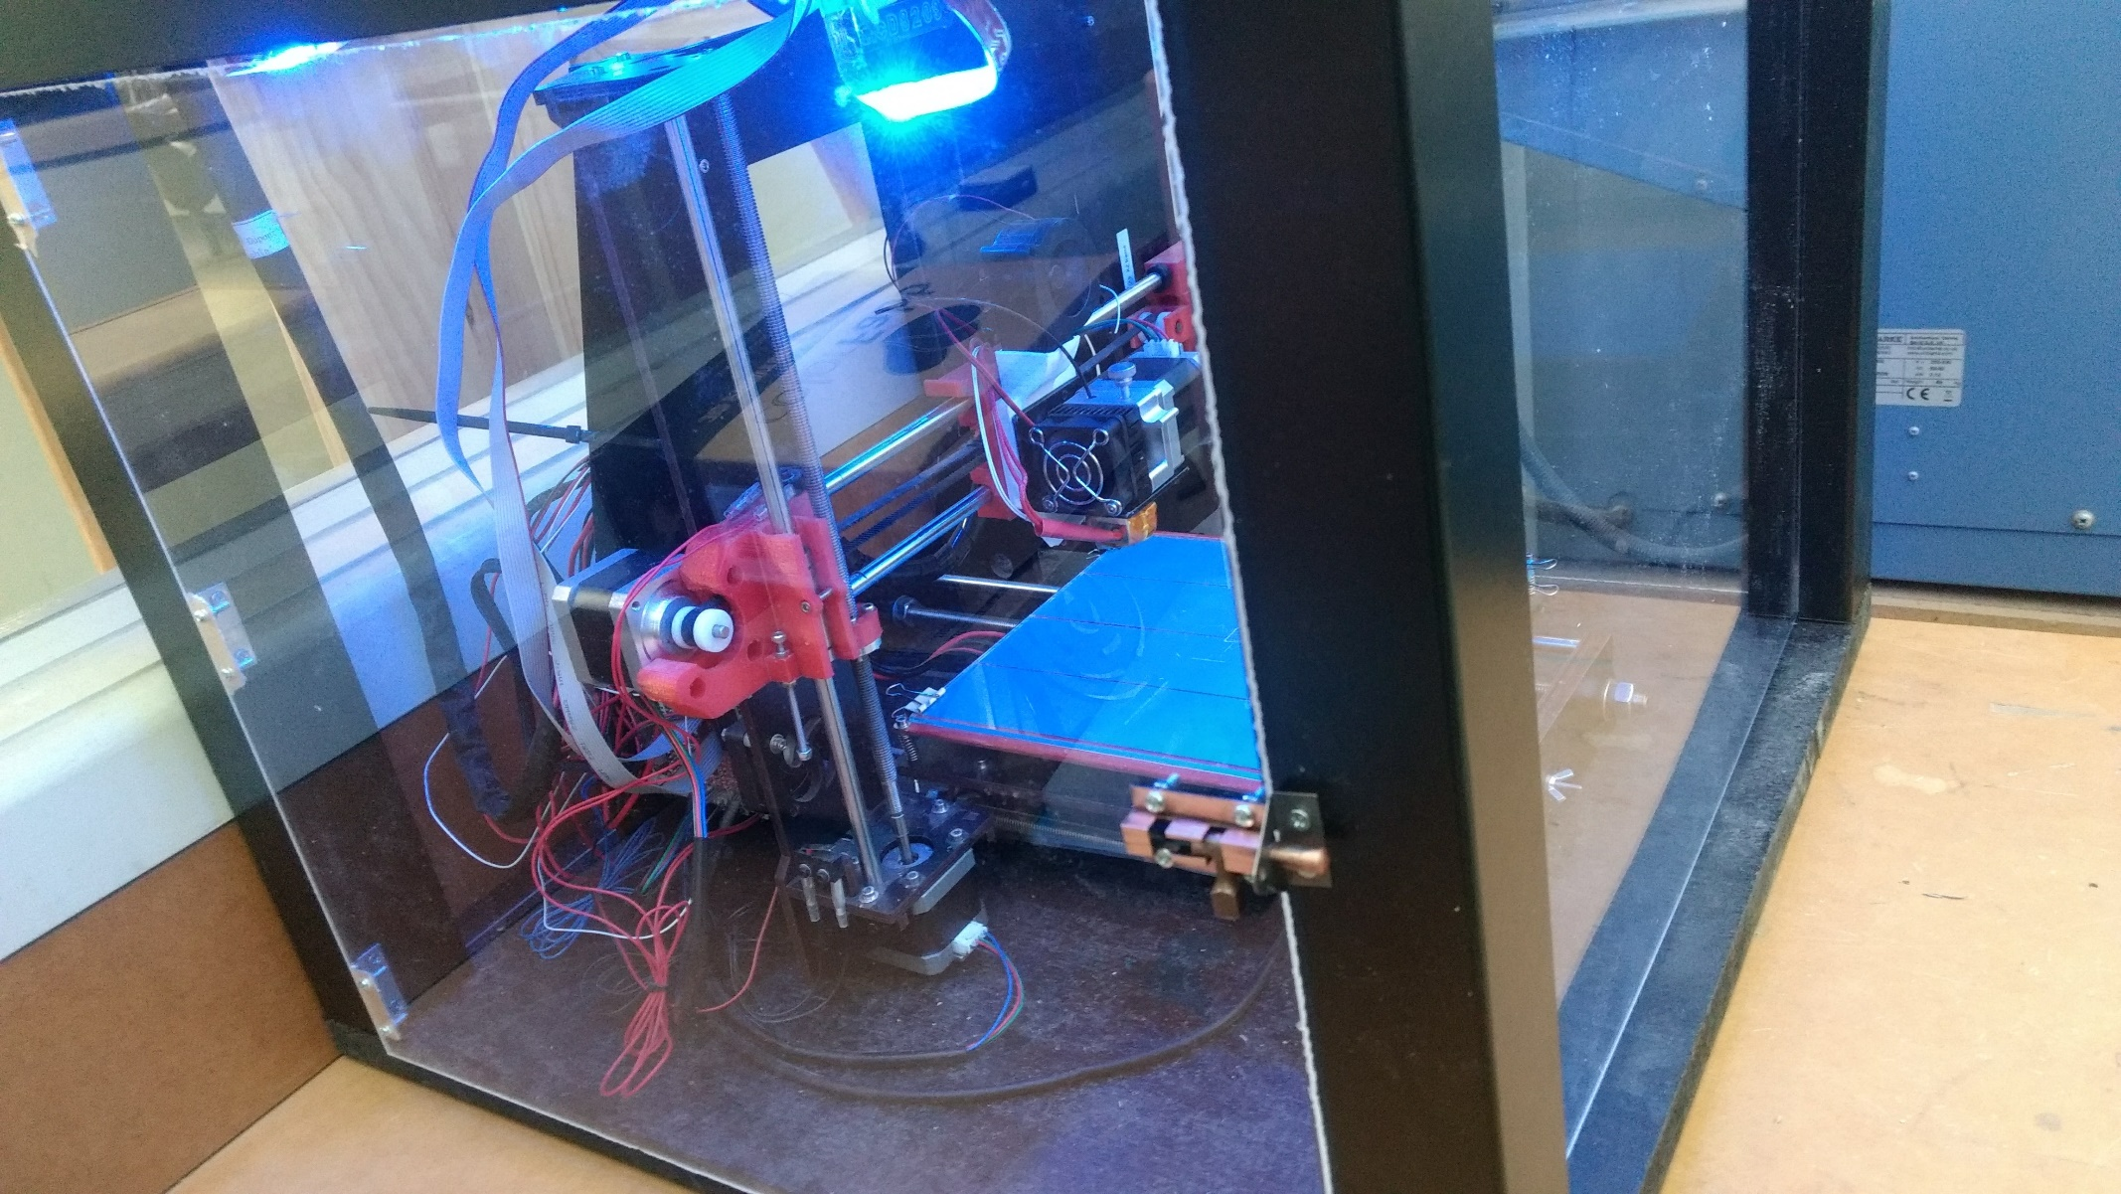

The enclosure is fully assembled

28/8/17

Testing.

|  |  |  |  |  |  |  |  |
| --- | --- | --- | --- | --- | --- | --- | --- |
| **Reason for the test** | **Process** | **Equipment list** | **Diagram of test** | **Expected outcome** | **Outcome** | | **Notes/Solution** |
| **Stringing/ Retraction**  The parts have been having the common issue of stringing. This means that the little bit of plastic in the end of the extruder as it moves without printing, leaks out and creates small strings across the part. | Testing different settings of retraction to allow the extruder to actually pull back the plastic as it makes these travel moves to reduce pressure on the output of plastic. | - 3D printer  - Model to display stringing  - Slicing software, such as Cura or Simplify3D |  | The first test print of my part (left) designed in Fusion 360 to display the stringing as well as possible quite clearly shows how bad the problem was with my default settings. After researching the causes of this problem, I found that a key problem is actually to do with the slicer settings – the program that converts a 3D model to the G-code that acts as instructions for the printer. I found the settings that relate to “retraction”, which are the settings that control the extruder motor reversing to pull back plastic but also the “coasting” (the length the extruder turns off for before reaching the edge), “wipe distance” (the distance the extruder wipes on the edge of the part, before retracting). I found that all of these settings were disabled by default, shown by the top screenshot under “ooze control”. But I then enabled them and set them to values that seemed appropriate. The second picture of the test correlates to the settings in the bottom screenshot, and the improvement is so clear, almost no plastic in between the two pillars, while also feeling just as strong. | | | |
| **Power supply voltage/ current**  Making sure the correct amount of voltage is being supplied to the components is highly important | Using a multimeter, set on the DC voltage setting, connect the two probes to the voltage input pins on the motherboard (Power supply pins are enclosed and inaccessible) | - 3D printer  - Multimeter |  | | | While the expected result would be to get 12V there are always other variables that effect the output voltage of electricity, such as resistance of wires etc. I ended up getting a reading of 13.16V which is actually a fair amount above the expected output. One possible solution would be to adjust the trimpot on the power supply, however, this would actually need readjusting at every new location the printer is plugged in, as the differences in the wall voltage output, create these small fluctuations in output voltage. Usually the default calibration is actually okay, as it is better to be supplying just over 12V rather than under. Due to the schools need for high power electricity the voltage is actually above the usual 240V. | |
| **Print Speed**  The aim of this test is to fully qualify the printers ability to reach high speeds, and therefore create prototypes more quickly | Printing a hollow rocket ship, starting at 60mm/s slowly increasing throughout the build up to 350% of the original speed (210mm/s) | - 3D printer  - Rocket model  - LCD to control speed |  | The expected outcome would be that the model slowly deteriorates in print quality throughout the process, however, up to the top of the print, the quality is actually quite consistent. The layers stay in their correct positions right up to the point where it reached 350%, at this point however there was also the added factor of the small layers, because they are smaller, the time it takes to print a single layer is much less, and therefore the plastic has less time to cool, which is probably more of the reason for the deformation. One possible solution to this would be to add even greater cooling mechanisms directly onto the print, however, as even most high end FDM printers don’t recommend print speeds of 210mm/s, I don’t think that there is a big problem here. The model took 40 minutes to print, which is an impressive speed, however it could have been even shorter if set on a faster speed for the whole build, possibly slowing down for the last few layers. | | | |

Evaluation.

On the whole my project ran much more smoothly than it could have due to my extensive research and investigation in the area of 3D printing. While I didn’t reference all the sources I found on the topic of 3D printing, I think I would have been lost in the process without them. There are so many variables that effect the printer’s quality, or even ability to print, and the research, while it didn’t allow me to immediately have a working printer, it allowed me to quickly diagnose and iterate on my printers capability, therefore improving the printer to the best of my ability. The design and planning of my printer helped me narrow down features I felt were necessary for my printer, while also calculating the amount of parts I would be able to access and use for the build, considering factors such as the budget. I 3D printed and purchased the printer components as economically as possible, and therefore the plans and designs were of the utmost importance. While the initial designs were straight forward, I think more detail in some of the specifics would have helped me complete the build more quickly as a whole, allowing for less time to be spent on the project overall. While my production phase was fairly efficiently completed as per the design documents, as mentioned above, more time spent planning the project could have sped up the process, while also could have smoothed out any areas that presented issues later for the build process. The planned timeline was not very generous and only left me small amounts of time for completing multiple steps. The estimated dates were therefore almost all before the days that I actually completed steps. One other thing that needed changing in the production plan was the allocation for the testing of the product throughout the whole process. I originally planned a large block just for testing at the end. I now understand that it makes more sense to test, improve, build, test, improve, build, all along the way.

**My constraints from the design brief and the outcome:**

|  |  |
| --- | --- |
| * Creates 3D prototypes | It successfully creates 3D prototypes of parts. |
| * Must use CAD | It can print CAD models successfully. |
| * Must be innovative in some way, making it unique | The inclusion of a RGB LED strip to be used as a peripheral indicator to the user of the current machine state is a unique innovation of the printer. |
| * Reasonably fast and efficient | It has a good speed, and has reached speeds of 210mm/s which is much higher than most high end “prosumer” grade printers are able to print at. |
| * Safe power system | While the original power supply setup was not safe for the user, the improved power supply enclosure contains all of the potentially dangerous 240V power wires. |
| * Must be reasonably priced – maximum of $500 | The overall build comes in at just under $500 so passes this but could have done better, by perhaps better original research, reducing the need for reordering components. |

So yes it successfully satisfies all of the constraints.

**The considerations:**

|  |  |
| --- | --- |
| * Easy to use | This machine is easy to operate for someone with an understanding of 3D printers. For people not familiar with 3D printers an extensive visual manual would help make the process more fluid |
| * Humidity controlled | After the research of the complications of humidity control, it seems that the process of dehumidification is quite complex, therefore the printer does not control the humidity directly (although the high temperatures generally lower the humidity). However what the printer does, is indicate humidity levels, allowing the user to insert packets of silica gel or use a dehumidifier for example to reduce humidity levels. |
| * Should be safe | The printer is safe due to the enclosure, however there are potential risks if you are operating the machine, due to the heated end, and also the moving parts that have reasonable strength i.e. risk of crushing. A possible solution would be to have a safety instruction manual, helping the user control the risks more effectively. |
| * Should be good quality | The overall build is of a high quality for a product with this budget. |
| * Requires minimal maintenance | The final printer is somewhat temperamental, I would expect in the long term it would need regular maintenance, or someone with the ability to diagnose print issues. |
| * Cables should be well organized | The cables are organized using many zip-ties, and also a cable tidy holding all of the extruder wires into one big cord. This solution works, however enclosing the main section of wires in a box, would help the overall printer look much tidier on the whole. |
| * Decent quality parts | The parts that it produces are of a quality high enough for the needed applications such as prototyping, being dimensionally accurate. |
| * Reasonably noiseless | The enclosure helps the printer as a whole remain fairly noiseless |

Not all of the design considerations have been met, however a significant attempt has been made to fulfil these to the best of my ability given the prioritized constraints including time. The system could be improved for ease of use by upgrading cheaper components to high quality versions. This would improve print quality and reliability, for example, the threaded rod that is used to move the z-axis is not necessarily straight, and this can be seen in some prints, where the edges seem to have a wiggly pattern that matches that of the thread pitch. Therefore replacing that with a high quality lead screw and also metal couplings rather than the simple plastic ones would definitely improve the quality. I could also replace much of the plywood frame with more sturdy metal plate and threaded rod, allowing for more tight connections and less space for unwanted movement in the printer.

Overall I was pleased with the outcome of my printer project and also the ability it had to create real three dimensional objects from the spool of plastic, the minimalist indicator LEDs allowing for an easy way to monitor prints. The design and modification process was very interesting extending my knowledge on the topic of 3D printing, and the end result was greater than just that of the material 3D printer, it was the greater expansion of my engineering knowledge and interest.

**Appendix of 3D printing terminology**

**Raft –** A few layers of plastic that are under the part during printing, but removed later. A raft will help make the part level, but also reduce the chance of warping with larger parts.

**Supports –** Exactly as the name suggests, these are printed plastic supports that help the printer produce parts with big overhangs or slopes (or even traditionally impossible prints, such as starting features in mid-air). They are removed once the print is finished, and allow for a greater degree of quality.

**Warping –** the name given to the defect in a part whereby the corners of a large surface lift from the print bed.

**Overhang –** A feature in a part that extrudes out from the main body hanging over the air.

**Bridging –** The printer printing material over an air gap on a part.

**Hotend** – The heated end of the printer that melts the plastic.

**Heated Bed –** The plate that the printing is done upon, with the ability to heat up to a desired temperature.

**Endstops –** A small micro-switch that alerts the printer of its maximum dimensions for travel

**References**

1: <https://makerhacks.com/ikea-3dprinter-enclosure/>

2: <http://www.instructables.com/id/Total-Metal-Hypercube-3D-Printer-no-Printed-Parts/>

3: <https://www.3dhubs.com/3d-printers/lulzbot-taz-6>

4: <https://ultimaker.com/en/products/ultimaker-2-plus>

5: <https://printm3d.com/themicro/>

6: <http://3dprintingsystems.com/products/3d-printers/up-boxplus-3d-printer/>

7: <http://www.ebay.com.au>

8: <http://www.bunnings.com.au>

9: <https://www.3dprintergear.com.au/>

10: <https://learn.adafruit.com/character-lcds/wiring-a-character-lcd>

11: <http://www.instructables.com/>

12: <https://www.thingiverse.com/>

13: <https://www.youtube.com/user/TheMakersMuse>

14: <https://www.youtube.com/user/cadcamstuff>

15: <https://www.youtube.com/user/AutodeskFusion360>

16: <https://www.arduino.cc/>

17: <https://www.autodesk.com/products/fusion-360/>

18: <http://fritzing.org/download/>

19: [www.3d-printing-technologies.com](http://www.3d-printing-technologies.com)

20: <https://forum.arduino.cc/>

21: <http://reprap.org/>

22: <http://3dprintingfromscratch.com/common/how-to-build-a-3d-printer-from-scratch/>

23: <https://3dprint.com/23080/instructables-build-3d-printer/>

24: <http://www.3ders.org/3d-printer/how-to-build-3d-printer.html>

25: <http://www.techradar.com/how-to/computing/how-to-build-your-own-3d-printer-1323663>

26: <https://all3dp.com/>

27: <http://openbuilds.org/?id=272>

28: <https://www.printablescenery.com/knowledgebase/buying-a-3d-printer/>

29: <http://hackaday.com/2016/07/06/build-a-3d-printer-workhorse/>

30: <https://www.3dhubs.com/>

31: <https://3dprinterchat.com>

32: <https://www.gizmodo.com.au/2016/02/your-desktop-3d-printer-could-pose-a-health-risk/>

33: <http://reprap.org/wiki/Calibration>

34: <https://reprage.com/post/46062359808/quick-guide-to-calibrating-the-scale-of-your-3d-printer>

35: <https://ultimaker.com/en/community/16792-whats-the-best-distance-between-nozzle-and-bed-when-leveling>

36: <http://forums.reprap.org/read.php?1,495579>

37: <http://www.urbanexile.net/2016/12/3-tips-for-the-prusa-i3-mk2/>

38: <http://print.theporto.com/posts/how-to-calibrate-your-3d-printer-for-accurate-printing/>